**Approving Expense Reports in Workday:**

1. Go to Workday <https://www.myworkday.com/yale/d/home.htmld>. Click on the “Inbox” Worklet or click your *Name* and then *Inbox* in the upper right hand corner of the page.

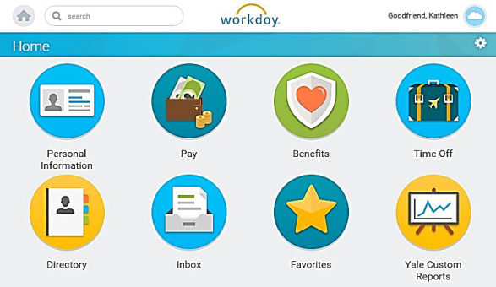

1. Under the *Actions* tab, click on the expense report that you want to approve. This will automatically bring up the details.

* If the amount, business purpose, and account charging look correct, select “Approve”.
* If changes need to be made, select “Send Back” – this will send the expense report back to the preparer for editing. You should complete the “Reason” field with the reason why you are sending back the expense report.

3. Click on “Done” - The business process event moves to the next step and this action item disappears from your *Actions* tab. Your approved business processes are added to your *Archive* tab.

**Approving Expense Reports via Mobile Application:**

1. Download the mobile Application – instructions can be found at <http://workday.training.yale.edu/training-materials/using-mobile-devices-workday>
2. Click on the Workday icon on your phone
3. Then, Click on the Inbox Worklet
4. Select the Expense Report you want to approve
5. Select “Approve” or Send Back”