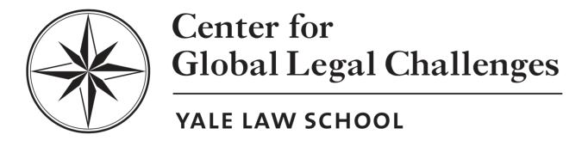
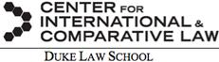

Yale-Duke Foreign Relations Law Roundtable

Friday, September 28, 2018
Faculty Lounge, Yale Law School
127 Wall Street, New Haven, CT 06511

Much of the focus of modern foreign relations law scholarship has been on the extent of presidential power and how this power has expanded over time. But Congress also has significant authority in this area. Moreover, in recent years, Congress has, at times, appeared to be more willing to assert itself in opposition to presidential foreign policy positions. Examples include Congress’s enactment of the Justice Against Sponsors of Terrorism Act (JASTA) over President Obama’s veto and Congress’s enactment of sanctions against Russia despite President Trump’s objections. In recent years, Congress has also attempted to engage more directly in diplomacy, not always in ways that are aligned with presidential policy. Additional conflicts between the two political branches appear to be likely in the coming years, such as over trade policy and the allocation of constitutional authority to terminate or withdraw from international agreements. Furthermore, questions are increasingly being raised about whether and to what extent Congress should attempt to rein in some of its broad delegations of foreign affairs authority to the executive branch. The prospect of divided government after the 2018 midterm elections raises the possibility of more robust efforts to press back against the president. This Roundtable will focus on Congress’s authority over foreign affairs, including the prospects for—and desirability and legality of—Congress exercising greater authority over foreign affairs.

FACULTY ORGANIZERS
Curtis Bradley (Duke University School of Law)

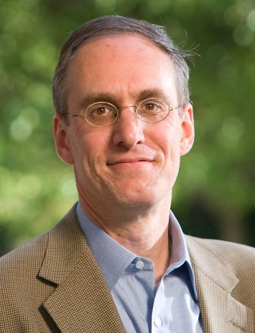
Curtis Bradley is the William Van Alstyne Professor of Law and Professor of Public Policy Studies at Duke University, as well as a co-director for the Center for International and Comparative Law. He was the founding co-director of Duke Law School’s Center for International and Comparative Law and serves on the executive board of Duke's Center on Law, Ethics, and National Security. Recently, he was appointed to serve as a Reporter on the American Law Institute's new Restatement project on The Foreign Relations Law of the United States.
Bradley graduated magna cum laude from Harvard Law School in 1988 and clerked for Judge David Ebel of the 10th U.S. Circuit Court of Appeals and Justice Byron White of the U.S. Supreme Court. After his clerkships, Bradley practiced law for several years at Covington & Burling in Washington, D.C. In 2004, he served as counselor on international law in the Legal Adviser's Office of the U.S. State Department. He is currently a member of the Secretary of State's Advisory Committee on International Law. Bradley has written numerous articles concerning international law, U.S. foreign relations law, and constitutional law. His most recent book, International Law in the U.S. Legal System, was published by Oxford University Press in 2013, and a second edition was published in 2015. He is currently working on a new book, tentatively entitled History’s Constitution: How Governmental Practices Define the Separation of Powers. His scholarship has been cited in over fifty judicial decisions.

Oona Hathaway (Yale Law School)
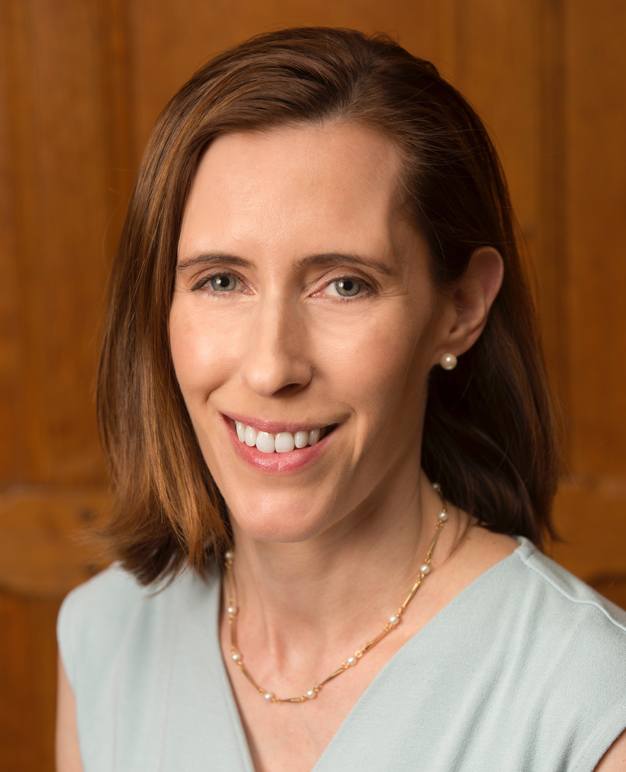
Oona A. Hathaway is the Gerard C. and Bernice Latrobe Smith Professor of International Law at the Yale Law School. She is also Professor of International Law and Area Studies at the Yale University MacMillan Center, on the faculty at the Jackson Institute for International Affairs, and Professor of the Yale University Department of Political Science. She is a Vice President of the American Society of International Law and member of the Advisory Committee on International Law for the Legal Adviser at the United States Department of State. In 2014-15, she took leave from Yale Law School to serve as Special Counsel to the General Counsel for National Security Law at the U.S. Department of Defense, where she was awarded the Office of the Secretary of Defense Award for Excellence.
Professor Hathaway earned her B.A. summa cum laude at Harvard University in 1994 and her J.D. at Yale Law School, where she was Editor-in-Chief of the Yale Law Journal, in 1997. She served as a Law Clerk for Justice Sandra Day O’Connor and for D.C. Circuit Judge Patricia Wald, held fellowships at Harvard University’s Carr Center for Human Rights Policy and Center for the Ethics and the Professions, served as Associate Professor at Boston University School of Law, as Associate Professor at Yale Law School, and as Professor of Law at U.C. Berkeley. Her current research focuses on the foundations of modern international law, the intersection of U.S. constitutional law and international law, the enforcement of international law, and the law of armed conflict. She is a principal investigator on a recent grant awarded by Hewlett Foundation to study cyber conflict. She has published more than twenty-five law review articles, and she is currently working on a book, The Internationalists: How a Radical Plan to Outlaw War Remade the World (with Scott Shapiro), which will be published by Simon & Shuster in 2017.

Harold Hongju Koh (Yale Law School)
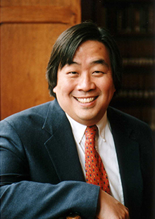
Harold Hongju Koh is Sterling Professor of International Law at Yale Law School. He returned to Yale Law School in January 2013 after serving for nearly four years as the 22nd Legal Adviser of the U.S. Department of State. He holds a B.A. degree from Harvard College and B.A. and M.A. degrees from Oxford University, where he was a Marshall Scholar. He earned his J.D. from Harvard Law School, where he was Developments Editor of the Harvard Law Review. Before coming to Yale, he served as a law clerk for Justice Harry A. Blackmun of the United States Supreme Court and Judge Malcolm Richard Wilkey of the U.S. Court of Appeals for the D.C. Circuit. Koh is one of the country’s leading experts in public and private international law, national security law, and human rights.
He first began teaching at Yale Law School in 1985 and served as its fifteenth Dean from 2004 until 2009. From 2009 to 2013, he took leave as the Martin R. Flug ’55 Professor of International Law to join the State Department as Legal Adviser, service for which he received the Secretary of State's Distinguished Service Award.
PARTICIPANTS

David Cohen (Wilmer Hale Law Firm)
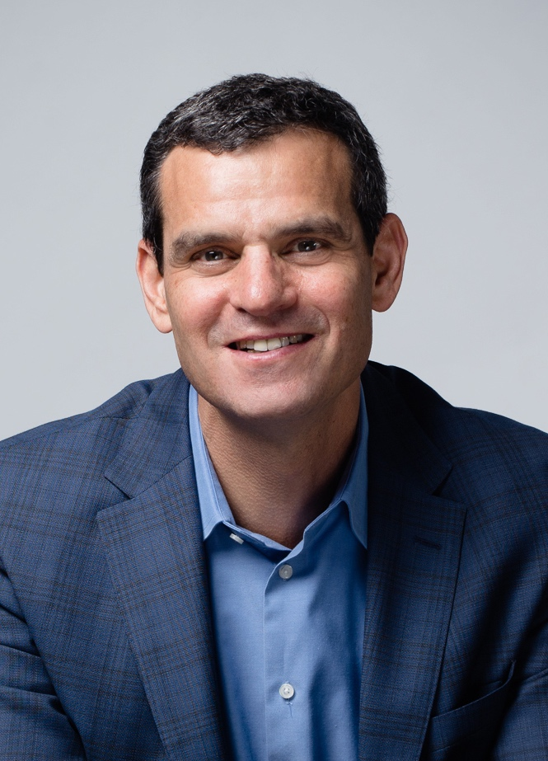
David Cohen is a partner in the Washington, DC office of WilmerHale and chair of the firm’s Financial and Business Integrity practice group. He is also a principal in WestExec Advisors, a geopolitical strategic consulting firm.
Before rejoining WilmerHale in 2017, Mr. Cohen served for two years (2015-2017) as Deputy Director of the Central Intelligence Agency (CIA), where he helped manage the Agency's operations, including foreign intelligence collection, all-source analysis, covert action, counter-intelligence and foreign liaison relationships.
Previously, Mr. Cohen served for four years (2011-2015) as Under Secretary of the Treasury for Terrorism and Financial Intelligence, where he supervised the department's policy, regulatory, enforcement and intelligence functions aimed at combating illicit finance, including money laundering and other financial crime, and disrupting financial support to nations, organizations and individuals posing a threat to national security. Early in the administration (2009-2011), Mr. Cohen served as Assistant Secretary of the Treasury for Terrorist Financing, overseeing policy development related to sanctions and money laundering.
Before joining the Obama administration in 2009, Mr. Cohen practiced law in Washington DC for nearly 20 years. He is a 1989 graduate of Yale Law School and the 1985 graduate of Cornell University.

Kristina Daugirdas (University of Michigan Law School)

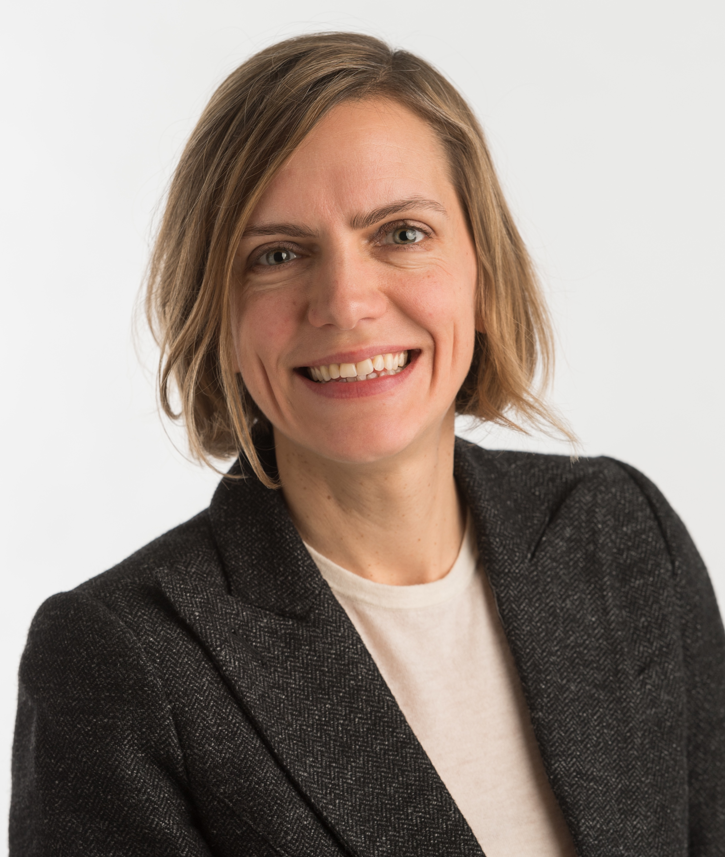
Kristina Daugirdas is a Professor of Law at the University of Michigan Law School. She teaches and writes about international law, international institutions, and U.S. foreign relations law. Professor Daugirdas is a member of the editorial board for the International Organizations Law Review.
In 2016-2017, Professor Daugirdas was a Visiting Fellow at the Graduate Institute in Geneva and worked as a consultant for the World Intellectual Property Organization. From 2014-2017, she co-authored the Contemporary Practice of the United States section of the American Journal of International Law. In 2014, Professor Daugirdas was awarded the Francis Deák Prize for her article titled “Congress Underestimated: The Case of the World Bank.”

Before joining the Michigan Law faculty, Professor Daugirdas served as an attorney-adviser at the U.S. Department of State and as a law clerk to Judge Stephen F. Williams of the District of Columbia Circuit Court of Appeals. She earned her JD, magna cum laude, from the New York University School of Law, and her AB, with honors, from Brown University.

Ashley Deeks (University of Virginia Law School)
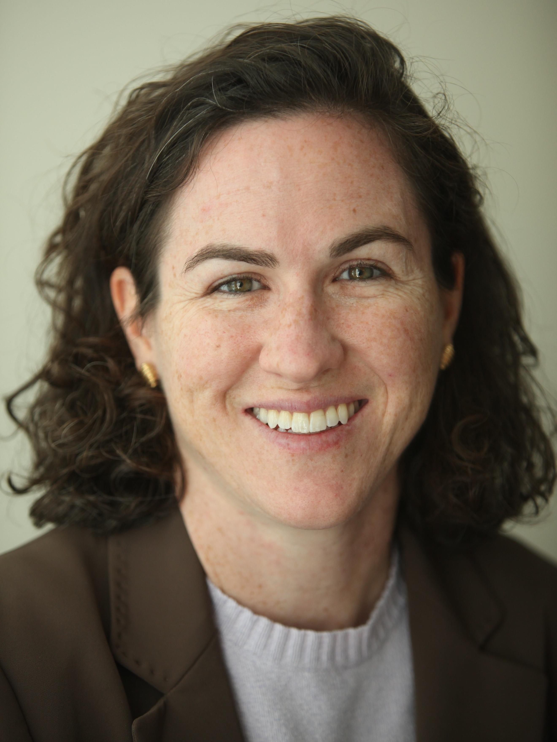
Ashley Deeks is a professor of law at the University of Virginia Law School, which she joined in 2012 after two years as an Academic Fellow at Columbia Law School. Her primary research and teaching interests are in the areas of international law, national security, intelligence, and the laws of war. Earlier she served as the assistant legal adviser for political-military affairs in the U.S. Department of State’s Office of the Legal Adviser. In 2005, she served as the embassy legal adviser at the U.S. Embassy in Baghdad. Deeks was a 2007-08 Council on Foreign Relations International Affairs Fellow. She received her J.D. with honors from the University of Chicago Law School, where she served on the Law Review, and clerked for Judge Edward R. Becker of the U.S. Court of Appeals for the Third Circuit.
Deeks is a member of the U.S. State Department’s Advisory Committee on International Law, the supervising editor for AJIL Unbound, and a senior contributor to the Lawfare blog.

Kristen Eichensehr (UCLA School of Law)

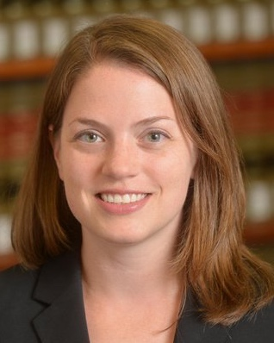
Kristen Eichensehr is an Assistant Professor at UCLA School of Law. She writes and teaches about cybersecurity, foreign relations, separation of powers, and national security law. Her recent scholarship has appeared or is forthcoming in the University of Pennsylvania Law Review, University of Chicago Law Review, and Virginia Law Review.
Before joining the UCLA faculty, Eichensehr clerked for Justices Sandra Day O’Connor and Sonia Sotomayor of the Supreme Court of the United States and for Chief Judge Merrick B. Garland of the U.S. Court of Appeals for the D.C. Circuit.
Eichensehr also served as Special Assistant to the Legal Adviser of the U.S. Department of State and practiced at Covington & Burling LLP in Washington, D.C. She received her J.D. from Yale Law School, an M.Phil. in International Relations from the University of Cambridge, and an A.B. in Government from Harvard University. Eichensehr is a former term member of the Council on Foreign Relations, a former visiting fellow at the Hoover Institution, an affiliate at the Stanford Center for International Security and Cooperation, and an affiliate scholar at the Center for Internet and Society at Stanford Law School. She is a member of the editorial board of Just Security.

Jean Galbraith (University of Pennsylvania School of Law)

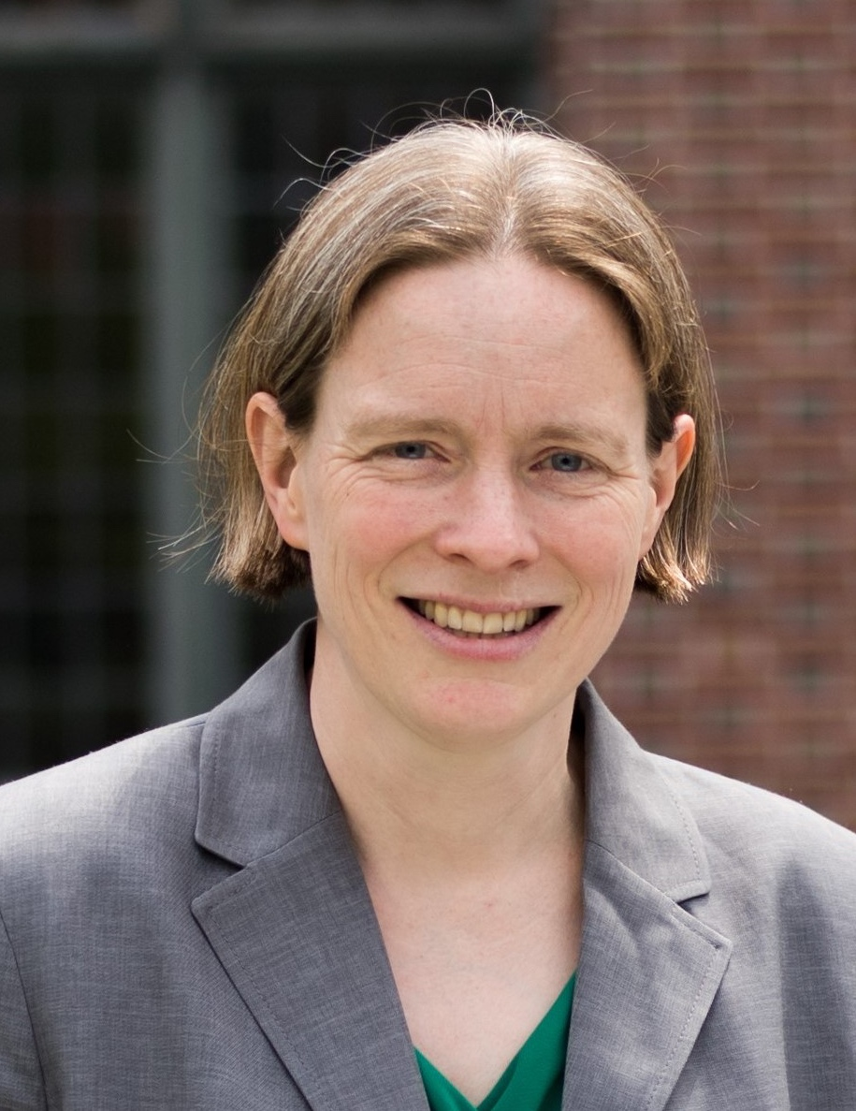
Jean Galbraith is a Professor at the University of Pennsylvania Law School, where she focuses on U.S. foreign relations law and public international law. Her work addresses the allocation of legal authority among U.S. governmental actors and, at the international level, between domestic actors and international regimes. Professor Galbraith has published in the Cornell Law Review, the Michigan Law Review, the NYU Law Review, the University of Chicago Law Review, the Virginia Law Review, and numerous international law journals. She currently serves as the editor of the Contemporary Practice of the United States (CPUS) section of the American Journal of International Law.

Professor Galbraith received her B.A. summa cum laude from Harvard University and her J.D. from the University of California, Berkeley, School of Law. After graduating law school, she served as a law clerk at the D.C. Circuit (for Judge Tatel) and at the Supreme Court of the United States (for Justice Stevens). She also spent a year as an Associate Legal Officer at the International Criminal Tribunal for the former Yugoslavia (for Judge Meron). In 2017, by vote of the graduating 3L class, she received the Harvey Levin Memorial Award for Teaching Excellence.

Michael Glennon (Fletcher School of Law and Diplomacy, Tufts University)

Michael J. Glennon is Professor of International Law at the Fletcher School of Law and Diplomacy, Tufts University. He served as the Legal Counsel to the Senate Foreign Relations Committee in the 1970s. Glennon is a member of the American Law Institute, Council on Foreign Relations, and Board of Editors of the American Journal of International Law. His most recent book is Foreign Affairs Federalism, co-authored with Robert Sloane (OUP, 2016).

Rebecca Ingber (Boston University School of Law)

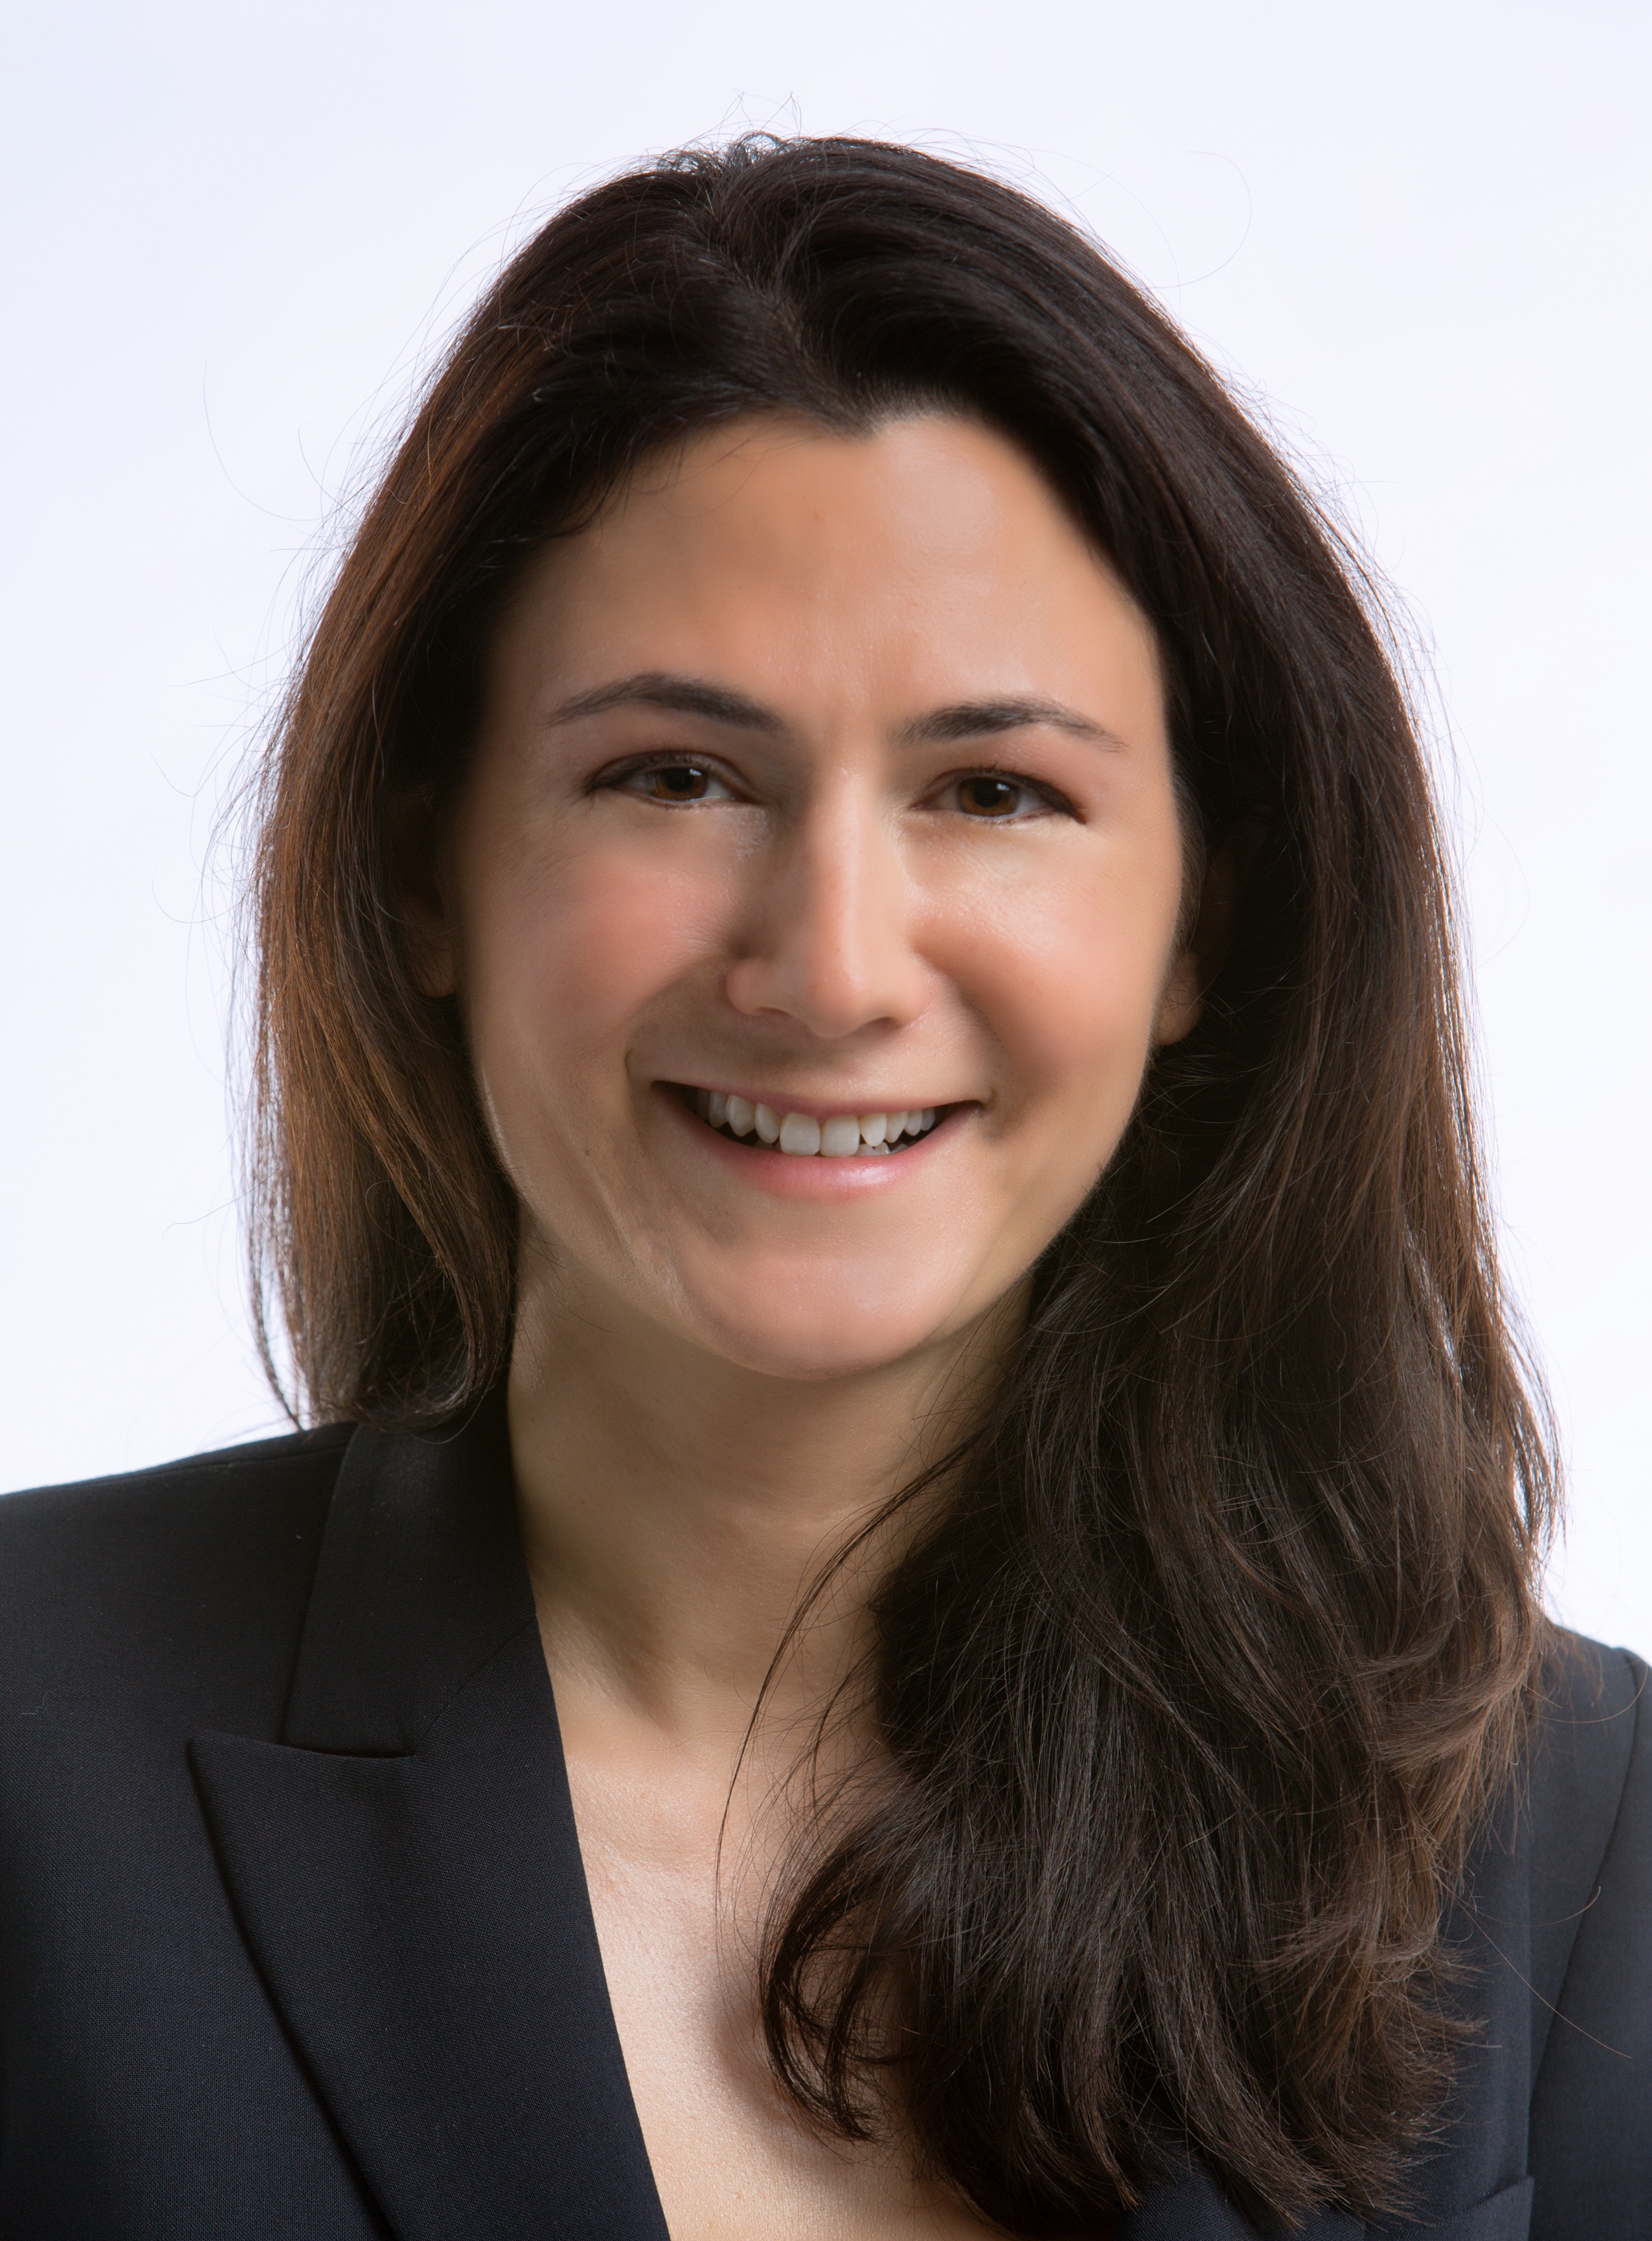
Rebecca Ingber is Associate Professor of Law at Boston University School of Law. She is a scholar of international and foreign affairs law, and has written about matters of national security, the laws of war, presidential power, and executive branch decision-making. Ingber received her BA from Yale University, her JD from Harvard Law School, and clerked for Judge Robert P. Patterson, Jr. of the Southern District of New York. She served for six years in the Office of the Legal Adviser at the US Department of State. There, Ingber worked on matters of diplomatic property, government contracts, and on litigation before the Supreme Court and the International Court of Justice in the Medellín and Avena cases. Additionally, she was a Council on Foreign Relations International Affairs Fellow (2011–2012); an Associate Research Scholar with the Project on Harmonizing Standards for Armed Conflict at the Columbia Law School Human Rights Institute (2012–2013); and an Associate-in-Law at Columbia Law School (2013–2015). Her work has been published or is forthcoming in the Harvard International Law Journal, the Yale Journal of International Law, and the Texas International Law Journal.
Douglas Kriner (Cornell University)

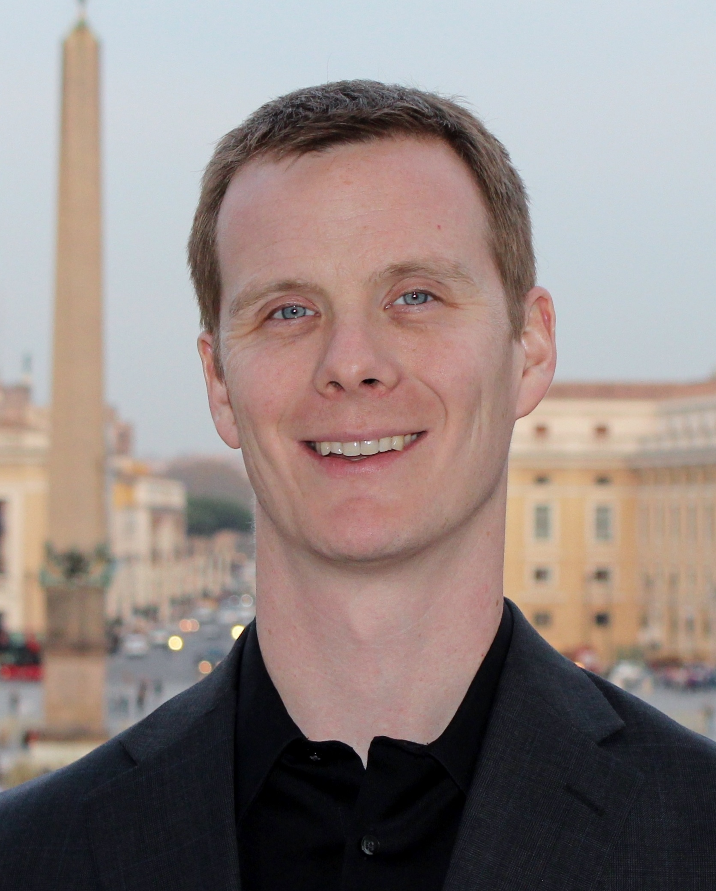
Douglas L. Kriner is a Professor of Government at Cornell University. He received his Ph.D. from Harvard University in 2006. His research interests include the presidency, Congress, and separation of powers dynamics. He has authored four books, most recently (with Eric Schickler) Investigating the President: Congressional Checks on Presidential Power, and (with Andrew Reeves) The Particularistic President: Executive Branch Politics and Political Inequality. His work has also appeared in American Political Science Review, American Journal of Political Science, and Journal of Politics, among other outlets.
Michael J. Mattler (U.S. Department of State)
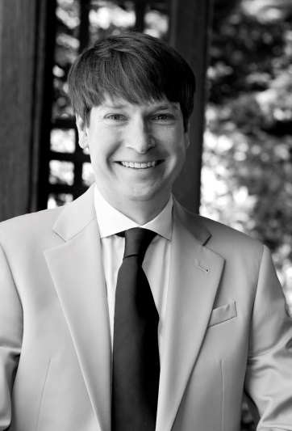
Michael J. Mattler is the Assistant Legal Adviser for Treaty Affairs at the U.S. Department of State. In this capacity, he is responsible for advising the U.S. Government on international and U.S. law related to the negotiation, conclusion, implementation, and interpretation of treaties and other international agreements. In prior work at the Department of State he has appeared twice before the International Court of Justice on behalf of the United States. He has also drafted, negotiated, and interpreted resolutions of the U.N. Security Council and General Assembly and advised on legal issues related to the International Criminal Court, the Middle East Peace Process, U.N. peacekeeping, and the use of armed force. Mr. Mattler received his B.A. with highest distinction from Indiana University and his J.D. magna cum laude from the New York University School of Law where he was Editor-in-Chief of the New York University Journal of International Law and Politics and a Junior Fellow at the law school’s Center for International Studies. He is a member of the American Law Institute.

Timothy Meyer (Vanderbilt University Law School)

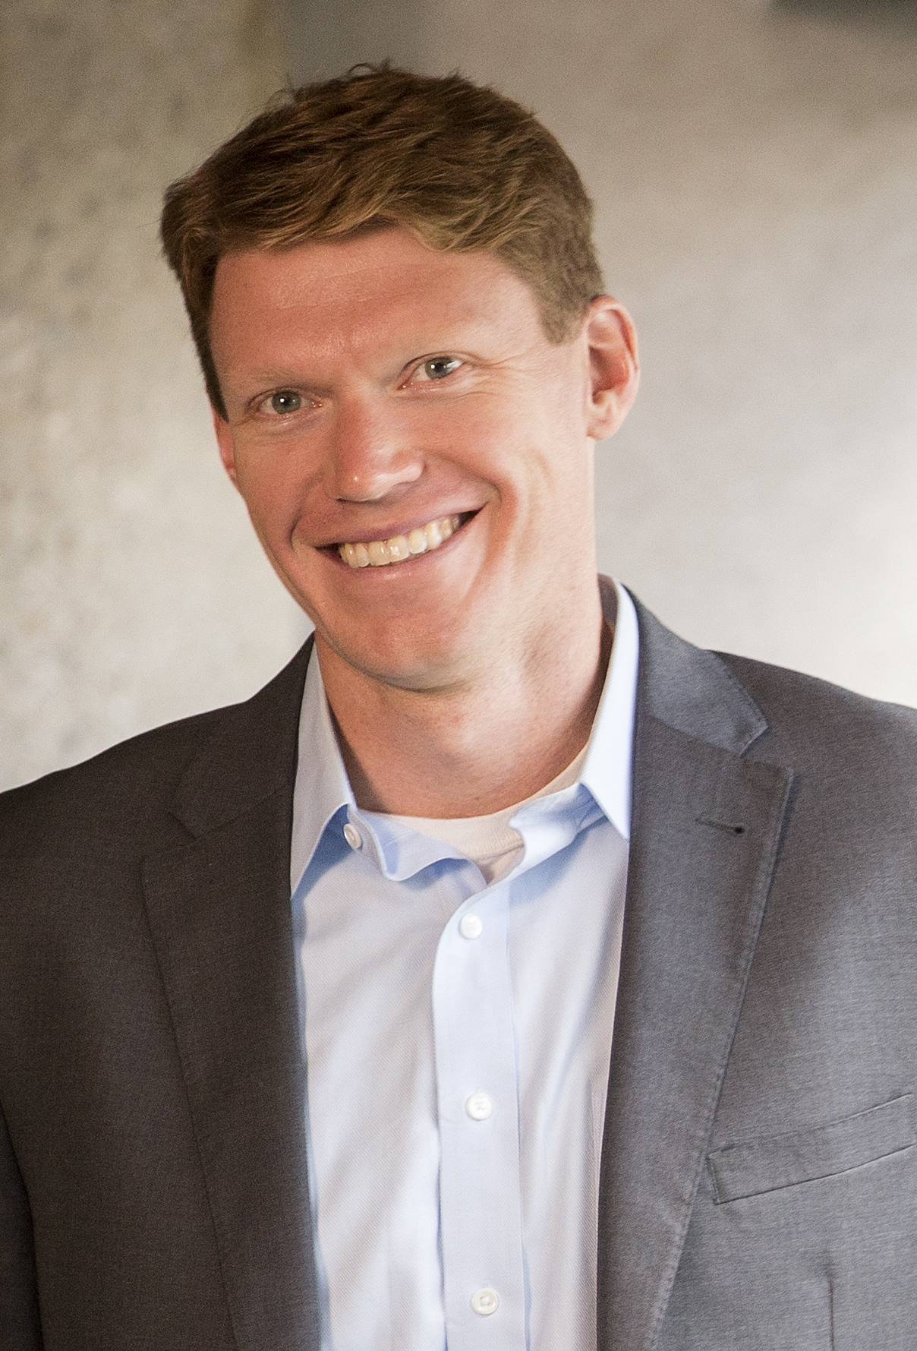
Timothy Meyer is the FedEx Research Professor, Professor of Law, and Director of the International Legal Studies Program at Vanderbilt University Law School.
Professor Meyer is an expert in public international law, with an emphasis on international economic and energy law. His current research examines how international economic agreements relate and respond to concerns about economic opportunity and inequality, as well as the role of the separation of powers in U.S. international economic policymaking. His past research has looked at the interaction of international and national rules on energy subsidies, the role of local governments in free trade agreements, and the creation of non-binding "soft law" obligations.

Andrew Olson (U.S. Senate Foreign Relations Committee)

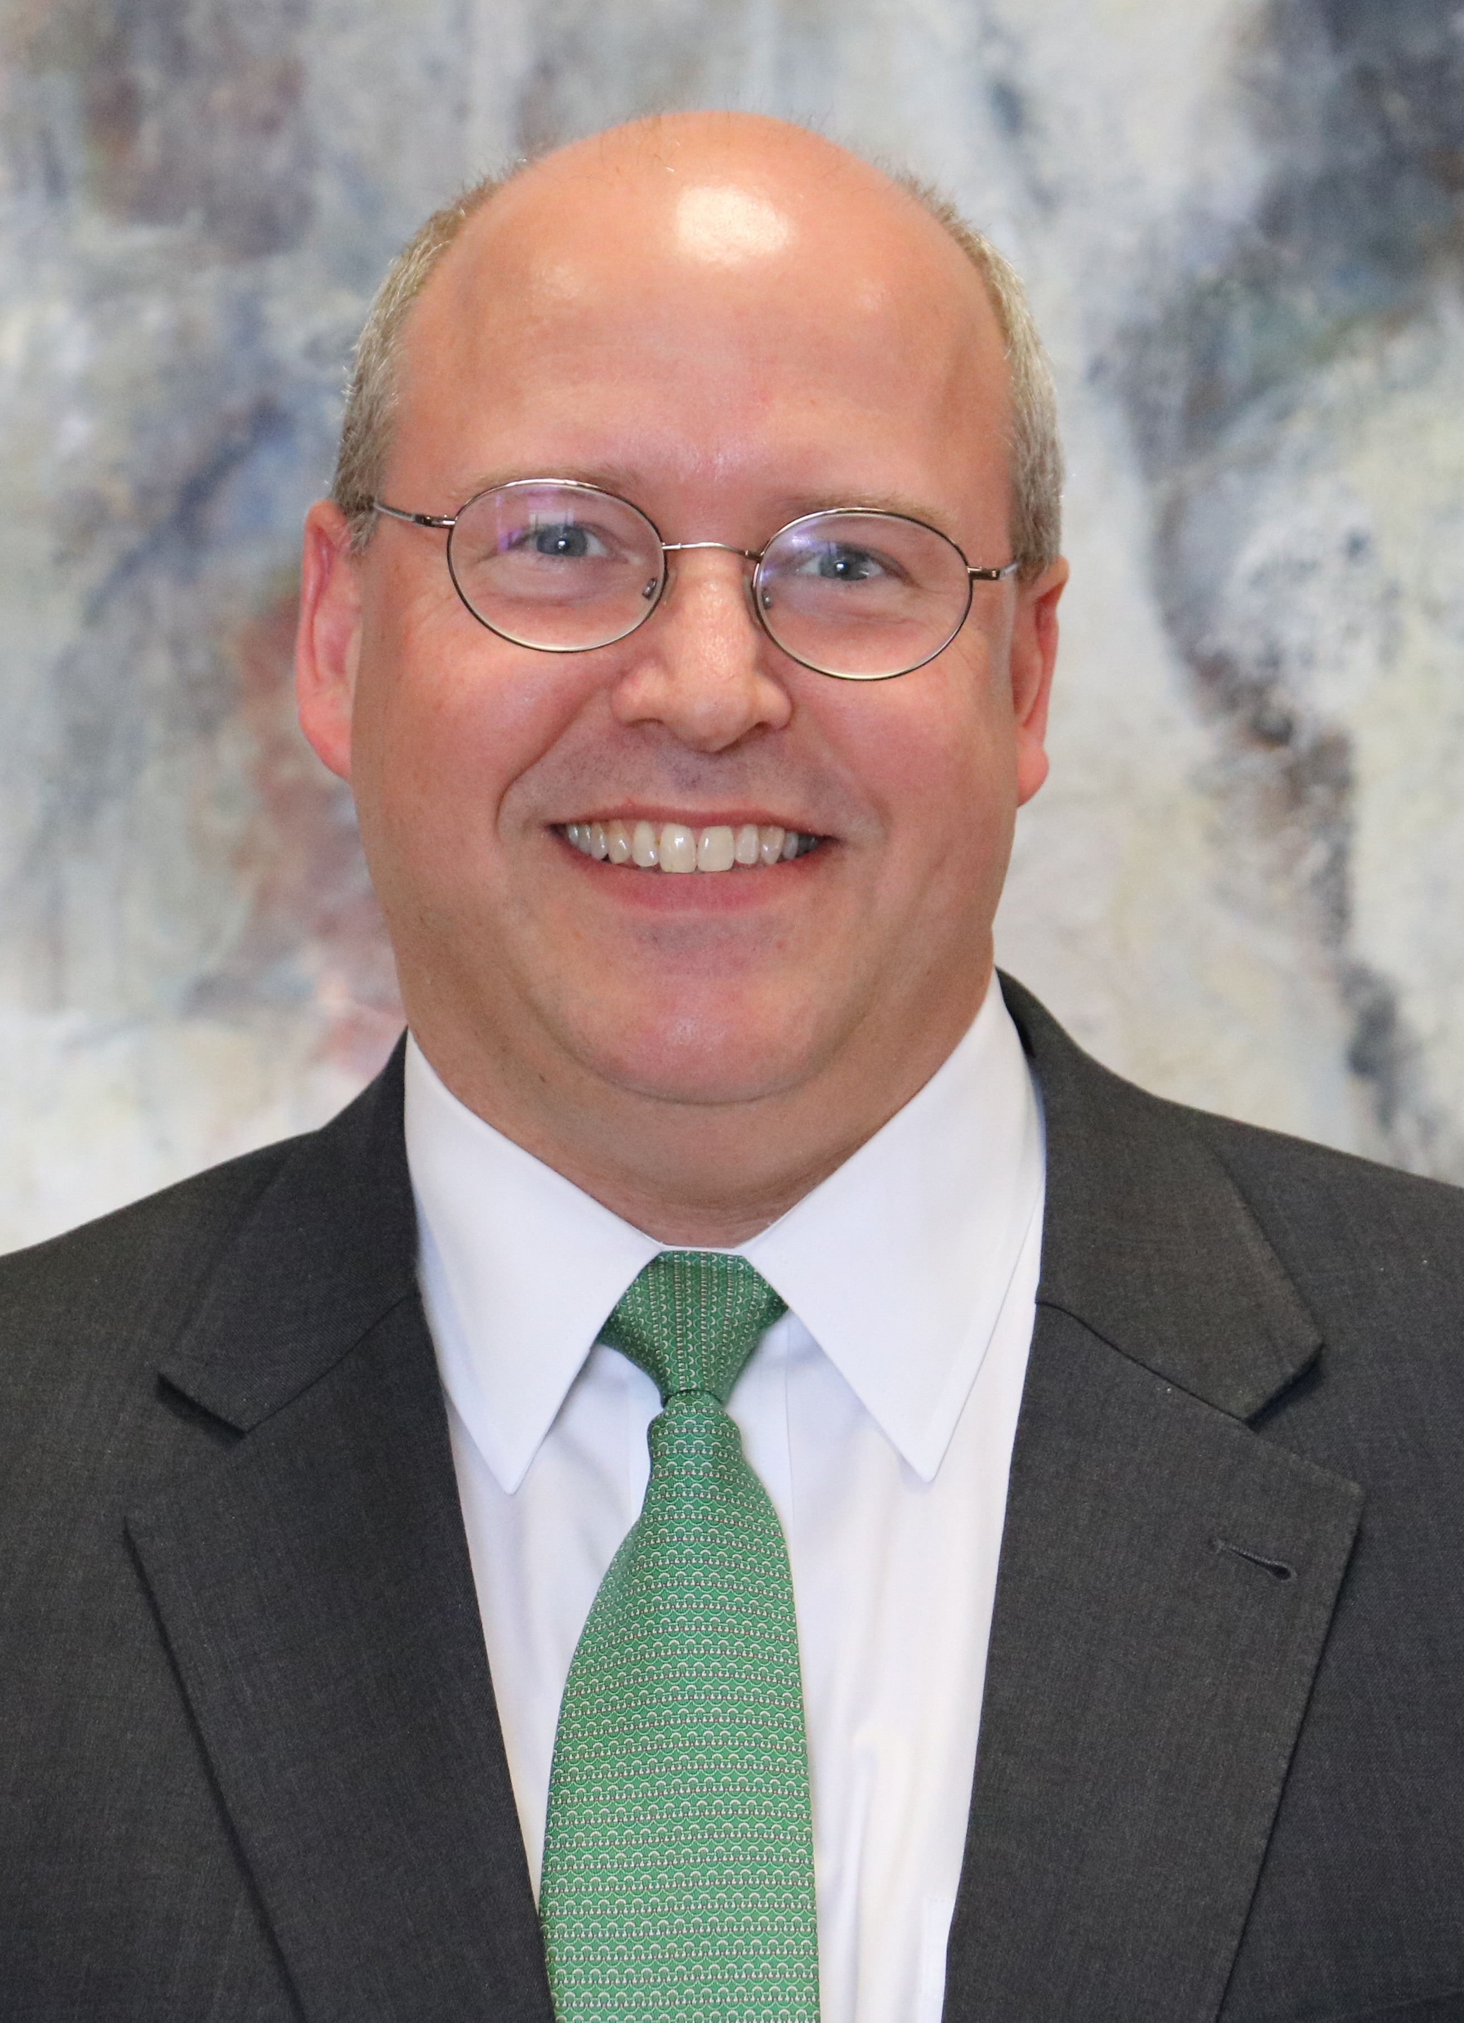
In 2013, Mr. Olson moved to the Senate Foreign Relations Committee from the trade and customs law firm of Sandler, Travis and Rosenberg, P.A. Mr. Olson serves as the chief economic advisor for Senate Foreign Relations Committee Chairman Senator Bob Corker (R-TN). His Committee responsibilities include international trade, investment, sanctions policy, business and commercial issues generally, international financial institutions, energy, environment, oceans, and the United Nations and related international organizations. He also serves as Treaty Counsel for the committee majority.

Previously, from 2009 to 2011, Mr. Olson served Senator Lindsey Graham (R-SC) as Republican Staff Director and Senior Counsel for the Disaster Recovery Subcommittee of the Senate Homeland Security and Government Affairs Committee and as Senator Graham’s principal advisor on defense and homeland security issues.

From 2005-2009, Mr. Olson served in the Office of the U.S. Trade Representative as Deputy Assistant and Assistant U.S. Trade Representative for Congressional Affairs. As one of the President’s chief liaisons with Congress for the Administration’s international trade agenda, he worked closely with the U.S. Trade Representative, White House and USTR senior staff to develop and implement U.S. trade policy.

From 2001-2005, Mr. Olson advised Senate Majority Leader Bill Frist (R-TN) on foreign policy, trade, and banking issues, including, from 2001 to 2003, managing Senator Frist’s responsibilities as Ranking Member and Chairman, respectively, of the Senate Foreign Relations Africa Subcommittee. From 1999-2001, Mr. Olson served as Legislative Counsel for foreign policy, trade, banking, energy, and tax issues for House Republican Policy Committee Chairman, Representative Christopher Cox (R-CA). From 1996-1999, as Research Associate, Mr. Olson assisted former U.S. UN Ambassador Jeane J. Kirkpatrick of the American Enterprise Institute with research for a book on UN peacekeeping.

Mr. Olson holds a B.A. History and Political Science from the University of Mississippi, 1990; a J.D. from the University of Missouri, 1994; and a M.A., International Affairs, George Washington University, 1998. Mr. Olson is licensed to practice law in Tennessee and the District of Columbia.

Saikrishna Prakash (University of Virginia Law School)
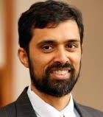
Saikrishna Prakash's scholarship focuses on separation of powers, particularly executive powers. He teaches Constitutional Law, Foreign Relations Law and Presidential Powers at the Law School.
Prakash majored in economics and political science at Stanford University. At Yale Law School, he served as senior editor of the Yale Law Journal and received the John M. Olin Fellowship in Law, Economics and Public Policy. After law school, he clerked for Judge Laurence H. Silberman of the U.S. Court of Appeals for the District of Columbia Circuit and for Justice Clarence Thomas of the U.S. Supreme Court. After practicing in New York for two years, he served as a visiting professor at the University of Illinois College of Law and as an associate professor at Boston University School of Law. He then spent several years at the University of San Diego School of Law as the Herzog Research Professor of Law. Prakash has been a visiting professor at the Northwestern University School of Law and the University of Chicago Law School. He also has served as a James Madison Fellow at Princeton University and Visiting Research Fellow at the Hoover Institution at Stanford University.
Among Prakash's articles are "50 States, 50 Attorneys General and 50 Approaches to the Duty to Defend," published in the Yale Law Journal; "The Imbecilic Executive," published in the Virginia Law Review; and "The Sweeping Domestic War Powers of Congress," published in the Michigan Law Review. He is the author of Imperial from the Beginning: The Constitution of the Original Executive (Yale University Press 2015).

Michael D. Ramsey (University of San Diego School of Law)
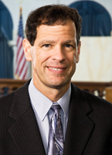
Michael D. Ramsey is Hugh and Hazel Darling Foundation Professor of Law at the University of San Diego School of Law, where he teaches and writes in the areas of Constitutional Law, Foreign Relations Law and International Law. He is the author of The Constitution’s Text in Foreign Affairs (Harvard University Press 2007), co-editor of International Law in the U.S. Supreme Court: Continuity and Change (Cambridge University Press 2011), and co-author of two casebooks, Transnational Law and Practice (Aspen 2015) and International Business Transactions: A Problem-Oriented Coursebook (12th ed., West 2015). His scholarly articles have appeared in publications such as the Yale Law Journal, the University of Chicago Law Review, the Georgetown Law Journal and the American Journal of International Law.
Ramsey received his B.A. magna cum laude from Dartmouth College and his J.D. summa cum laude from Stanford Law School. Prior to teaching, he served as a judicial clerk for Judge J. Clifford Wallace of the United States Court of Appeals for the Ninth Circuit and for Justice Antonin Scalia of the United States Supreme Court, and practiced law with the law firm of Latham & Watkins, where he specialized in international finance and investment. He has taught as a visiting professor at the University of California, San Diego, in the Department of Political Science, at the University of Paris – Sorbonne, in the Department of Comparative Law, and at the Kuwait International Law School in Kuwait City.

Ganesh Sitaraman (Vanderbilt University Law School)
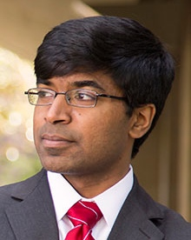
Ganesh Sitaraman is Professor of Law and Director of the Program on Law and Government at Vanderbilt Law School. Sitaraman is the author of The Crisis of the Middle-Class Constitution: Why Economic Inequality Threatens Our Republic (Alfred A. Knopf, 2017), which was one of The New York Times‘100 notable books of 2017, and The Counterinsurgent‘s Constitution: Law in the Age of Small Wars (Oxford University Press, 2012), which won the 2013 Palmer Civil Liberties Prize. An Eagle Scout and a Truman Scholar, he earned his A.B. in government magna cum laude at Harvard, a master‘s degree in political thought and intellectual history from Emmanuel College, Cambridge, where he was the Lionel de Jersey Harvard Scholar, and his J.D. magna cum laude from Harvard Law School, where he was an editor on the Harvard Law Review.

Margaret L. Taylor (U.S. Senate Foreign Relations Committee)

Margaret L. Taylor was the Democratic Chief Counsel and Deputy Staff Director for the Senate Foreign Relations Committee from 2015 until August 2018. She advised the Ranking Member and other Senators on all legal, legislative, and procedural aspects of the Committee’s work. She managed, for the Democratic side of the committee, the development and movement of legislation; oversight activities; and the consideration of treaties and Ambassadorial nominations. She served as Deputy Chief Counsel from 2013-2015. Ms. Taylor was an attorney in the Office of the Legal Adviser at the U.S. Department of State from 2003 to 2013. Among other things, she advised on Iran sanctions; foreign assistance program appropriations and implementation; as well as trafficking in persons, extradition, and other international law enforcement matters. From 2009-2010, Ms. Taylor was a Council on Foreign Relations International Affairs Fellow with the Center for Strategic & International Studies. She has served in the Antitrust Division of the U.S. Department of Justice and the U.S. Attorney’s Office for the Southern District of New York. She received a bachelor’s degree from Princeton University and a JD from Columbia Law School, where she was a Kent Scholar and served as Editor-in-Chief of the Columbia Law Review. After graduating from law school, Ms. Taylor clerked for the U.S. Court of Appeals for the Second Circuit. She was a term member of the Council on Foreign Relations from July 2011-July 2016.

Zoe Weinberg (Yale Law School/ Stanford Graduate School of Business)

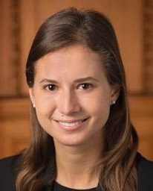
Zoe Weinberg is a JD/MBA candidate at Yale Law School and Stanford Graduate School of Business. Prior to graduate school, she worked on the Hillary for America campaign, serving as the assistant to the Chief Administrative Officer. Previously she worked at the International Finance Corporation at the World Bank, based in Washington, D.C. and Nairobi. She worked on projects in over a dozen countries, including Somalia, South Sudan, Rwanda, and Liberia. Prior to IFC, she worked in Goldman Sachs’s alternative investments group in New York. While in law school, she spent time in northern Iraq on the emergency humanitarian response for Mosul during the counter-ISIL operation, and worked as a summer associate at Wilmer Cutler Pickering Hale and Dorr in Washington, D.C.

At Yale Law School, Zoe served as Herbert J. Hansell Student Fellow of the Center for Global Legal Challenges, an Associate Fellow of the Greenberg World Fellows Program, and a Fellow of the Kerry Initiative at the Jackson Institute for Global Affairs. She also was a member of the Rule of Law Clinic and worked as a speechwriter for Dean Heather K. Gerken and former Dean Robert C. Post. She graduated from Harvard University in 2013 with a B.A. in Social Studies.

