CORPORATE DISCLOSURE STATEMENT

None of the amici has a parent corporation and no corporation owns 10% or more of any of the amici’s stock.
STATEMENT OF COMPLIANCE WITH RULE 29(c)(5)
Pursuant to Federal Rule of Appellate Procedure 29(c)(5), amici certify that no party’s counsel authored this brief in whole or in part, no party or party’s counsel contributed money that was intended to fund preparing or submitting this brief, and no person—other than amici or their counsel—contributed money that was intended to fund preparing or submitting this brief.

TABLE OF CONTENTS

TABLE OF AUTHORITIES iii
PRELIMINARY STATEMENT 1
INTEREST OF AMICI CURIAE AND CONSENT TO FILE 3
ARGUMENT 3
I. THE FIRST AMENDMENT PROTECTS THE ACT OF RECORDING MATTERS OF PUBLIC CONCERN. 3
A. Recorded Images Have Historically Contributed In Unique Ways To Important National Debates. 4
1. Images drew crucial attention to the civil rights movement. 5
2. Images deeply influenced views of the Vietnam War. 6
3. Bystander recordings have prompted debates on policing. 8
B. Recording Matters Of Public Concern Is Covered By The First Amendment As An Essential Precursor To Speech. 11
1. The First Amendment broadly seeks to protect the free flow of information on matters of public concern. 11
2. First Amendment protection extends specifically to the act of recording matters of public concern. 16
3. The right to record extends to all matters of public concern that one lawfully observes, even on private property. 20
II. IDAHO CODE § 18-7042(1)(d) VIOLATES THE FIRST AMENDMENT RIGHT TO RECORD. 24
A. The Same First Amendment Standards That Protect Speech Protect Recording Matters of Public Concern. 25
B. Section 18-7042(1) Is a Facially Content-Based Restriction That Cannot Survive Strict Scrutiny. 27
1. No compelling interest justifies Idaho’s restrictions on recording matters of public concern. 28
2. Idaho’s recording restriction is not narrowly tailored. 31
CONCLUSION 33
APPENDIX (List of Amici Curiae) 34

TABLE OF AUTHORITIES
Cases
ACLU of Ill. v. Alvarez,
679 F.3d 583 (7th Cir. 2012) 18, 26, 27
Anderson v. City of Hermosa Beach,
621 F.3d 1051 (9th Cir. 2010) 16, 24
Animal Legal Def. Fund v. Otter,
118 F. Supp. 3d 1195 (D. Idaho 2015) 28
Ashcroft v. ACLU,
542 U.S. 656 (2004) 17, 32
Bartnicki v. Vopper,
532 U.S. 514 (2001) 30
Branzburg v. Hayes,
408 U.S. 665 (1972) 14
Bridges v. California,
314 U.S. 252 (1941) 12
Brown v. Entm't Merch. Ass'n,
564 U.S. 786 (2011) 17
Buckley v. Valeo,
424 U.S. 1 (1976) 15
CBS, Inc. v. Davis,
510 U.S. 1315 (1994) 24
Cirelli v. Town of Johnston Sch. Dist.,
897 F. Supp. 663 (D.R.I. 1995) 19
Citizens United v. Fed. Election Comm’n,
558 U.S. 310 (2010) 16, 25, 28
City of Ladue v. Gilleo,
512 U.S. 43 (1994) 20
City of San Diego v. Roe,
543 U.S. 77 (2004) 30
Cohen v. Cowles Media Co.,
501 U.S. 663 (1991) 29
Comite de Jornaleros v. City of Redondo Beach,
657 F.3d 936 (9th Cir. 2011) 32
Connick v. Myers,
461 U.S. 138 (1983) 30
Curtis Pub. Co. v. Butts,
388 U.S. 130 (1967) 12
Demarest v. Athol/Orange Cmty. Television, Inc.,
188 F. Supp. 2d 82 (D. Mass. 2002) 19
Ex parte Thompson,
442 S.W.3d 325 (Tex. Crim. App. 2014) 19
FCC v. AT&T,
562 U.S. 397 (2011) 30
FCC v. League of Women Voters of Cal.,
468 U.S. 364 (1984) 17
FCC v. Pacifica Found.,
438 U.S. 726 (1978) 17
Fordyce v. City of Seattle,
55 F.3d 436 (9th Cir. 1995) 18
Garrison v. Louisiana,
379 U.S. 64 (1964) 12
Glik v. Cunniffe,
655 F.3d 78 (1st Cir. 2011) 19
Globe Newspaper Co. v. Superior Court,
457 U.S. 596 (1982) 12, 14
Hustler Magazine, Inc. v. Falwell,
485 U.S. 46 (1988) 11
Joseph Burstyn, Inc. v. Wilson,
343 U.S. 495 (1952) 17
Kleindienst v. Mandel,
408 U.S. 753 (1972) 12
Leathers v. Medlock,
499 U.S. 439 (1991) 18
Minneapolis Star & Tribune Co. v. Minn. Comm’r of Revenue,
460 U.S. 575 (1983) 15, 26
NAACP v. Button,
371 U.S. 415 (1963) 14
Near v. Minnesota,
283 U.S. 697 (1931) 12
New York Times Co. v. Sullivan,
376 U.S. 254 (1964) 12
People v. Clark,
6 N.E.3d 154 (Ill. 2014) 19
R.A.V. v. City of St. Paul,
505 U.S. 377 (1992) 20, 28
Ramos v. Flowers,
56 A.3d 869 (N.J. Super. Ct. App. Div. 2012) 19
Red Lion Broad. Co. v. FCC,
395 U.S. 367 (1969) 13
Reed v. Town of Gilbert,
135 S. Ct. 2218 (2015) 20, 27, 28
Richmond Newspapers, Inc. v. Virginia,
448 U.S. 555 (1980) 13, 14
Smith v. City of Cumming,
212 F.3d 1332 (11th Cir. 2000) 19
Snyder v. Phelps,
562 U.S. 443 (2011) 30
Sorrell v. IMS Health Inc.,
564 U.S. 552 (2011) 15, 27
State v. Bonner,
61 P.3d 611 (Idaho Ct. App. 2002) 19
Thornhill v. Alabama,
310 U.S. 88 (1940) 12
Time, Inc. v. Hill,
385 U.S. 374 (1967) 12
Turner Broad. Sys., Inc. v. FCC,
512 U.S. 622 (1994) 13, 18, 26, 29
U.S. v. Alvarez,
132 S. Ct. 2537 (2012) 28, 32
U.S. v. O’Brien,
391 U.S. 367 (1968) 29
U.S. v. Playboy Entm't Grp., Inc.,
529 U.S. 803 (2000) 17, 28
Universal City Studios, Inc. v. Corley,
273 F.3d 429 (2d Cir. 2001) 17
Vincenty v. Bloomberg,
476 F.3d 74 (2d Cir. 2007) 16
Statutes and Regulations
9 C.F.R. § 309.3 (2009) 24
Civil Rights Act of 1964, Pub. L. No. 88-352, 78 Stat. 241 6
Federal Meat Inspection Act of 1906, Pub. L. No. 59-242, 34 Stat. 1260 21
Idaho Code § 18-7042 passim
Pure Food and Drug Act of 1906, Pub. L. No. 59-384, 34 Stat. 768 21
Other Authorities
Agriculture Secretary Tom Vilsack Announces Final Rule for Handling of Non-Ambulatory Cattle, U.S. Dep’t of Agric. (Mar. 14, 2009),
http://www.usda.gov/wps/portal/usda/usdamediafb?contentid=2009/03/0060.xml 24
Al Baker, J. David Goodman & Benjamin Mueller, Beyond the Chokehold: The Path to Eric Garner’s Death, N.Y. Times (June 13, 2015),
http://www.nytimes.com/2015/06/14/nyregion/eric-garner-police-chokehold-staten-island.html 10
Anna Schechter, Tyson Foods Changes Pig Care Policies After NBC Shows Undercover Video, NBC News (Jan. 10, 2014),
http://investigations.nbcnews.com/_news/2014/01/10/22245308-tyson-foods-changes-pig-care-policies-after-nbc-shows-undercover-video 23
AP/Bill Hudson, Photograph of Parker High School Student Walter Gadsden Being Attacked by Dogs (1963),
https://upload.wikimedia.org/wikipedia/en/7/74/Birmingham_campaign_dogs.jpg 5
AP/Malcolm W. Browne, Saigon, Vietnam Buddhist Monk Thích Quảng Đức Sets Himself Ablaze to Protest the South Vietnamese Government (1963),
http://www.worldpressphoto.org/sites/default/files/styles/gallery_main_image/public/1963001.jpg 6
AP/The Toledo Blade, Image from Video Showing Slaughterhouse Worker Attempting to Force “Downed” Cow onto Its Feet by Ramming It with Forklift in Chino, Calif. (2008),
http://www.toledoblade.com/image/2013/03/17/800x_b1_cCM_z/Undercover-Video-Bills-3-18.jpg 22
Ashutosh Bhagwat, Producing Speech, 56 Wm. & Mary L. Rev. 1029 (2015) 14
Cynthia Galli, Angela Hill & Rym Momtaz, McDonald’s, Target Dump Egg Supplier After Investigation, ABC News (Nov. 18, 2011),
http://abcnews.go.com/Blotter/mcdonalds-dumps-mcmuffin-egg-factory-health-concerns/story?id=14976054 23
Daniel C. Hallin, The “Uncensored War”: The Media and Vietnam 3 (1989) 7
Davi Johnson, Martin Luther King’s 1963 Birmingham Campaign as Image Event, 10 Rhetoric & Pub. Affairs 1 (2007) 5
David Greenberg, How Teddy Roosevelt Invented Spin, The Atlantic (Jan. 24, 2016),
http://www.theatlantic.com/politics/archive/2016/01/how-teddy-roosevelt-invented-spin/426699/ 21
David J. Garrow, Foreword to Martin A. Berger, Seeing Through Race: A Reinterpretation of Civil Rights Photography 6
Demian Bulwa, Wyatt Buchanan & Matthew Yi, Behind Murder Charge Against Ex-BART Officer, SFGate (Jan. 15, 2009),
http://www.sfgate.com/bayarea/article/Behind-murder-charge-against-ex-BART-officer-3254683.php 9
Dolf Zillmann, et al., Effects of Photographs in News-Magazine Reports on Issue Perception, 1 Media Psychol. 207 (1999) 32
Douglas O. Linder, The Holliday Videotape, Famous Trials,
http://law2.umkc.edu/faculty/projects/ftrials/lapd/kingvideo.html 9
Eliott C. McLaughlin, We’re Not Seeing More Police Shootings, Just More News Coverage, CNN (Apr. 21, 2015),
http://www.cnn.com/2015/04/20/us/police-brutality-video-social-media-attitudes/ 11
Eugene Volokh, Freedom of Speech, Permissible Tailoring and Transcending Strict Scrutiny, 144 U. Pa. L. Rev. 2417 (1997) 29
Getty/John Filo, Mary Ann Vecchio Kneels over the Body of Jeffrey Miller at Kent State University, Ohio (1970),
http://www.slate.com/content/dam/slate/blogs/behold/2013/05/04/7.jpg.CROP.original-original.jpg 7
Getty/New York Daily News, NYPD Chokehold Death Ruled a Homicide (2014),
http://abcnews.go.com/US/nypd-chokehold-death-homicide-medical-examiner-rules/story?id=24811834 10
Haim Bresheeth, Projecting Trauma: War Photography and the Public Sphere, 20 Third Text 57 (2006) 7
Holly Yan, Attorney: New Audio Reveals Pause in Gunfire When Michael Brown Was Shot, CNN (Aug. 27, 2014),
http://www.cnn.com/2014/08/26/us/michael-brown-ferguson-shooting/index.html 10
Humane Society of the United States, Rampant Animal Cruelty at California Slaughter Plant (Jan. 30, 2008),
http://www.humanesociety.org/news/news/2008/01/undercover_investigation_013008.html 22
Joan Biskupic & Howard Kurtz, ‘48 Hours’ Wins 11th-Hour Case to Show Undercover Videotape, Wash. Post (Feb. 10, 1994),
https://www.washingtonpost.com/archive/politics/1994/02/10/48-hours-wins-11th-hour-case-to-show-undercover-videotape/06f56302-e2e2-4e5f-b62b-6078f80f3b91/ 24
Justin Marceau & Alan Chen, Free Speech and Democracy in the Video Age, 116 Colum. L. Rev. 991 (2016) 4
Karen Olsson, Welcome to The Jungle, Slate (July 10, 2006),
http://www.slate.com/articles/arts/books/2006/07/welcome_to_the_jungle.html 21
Kent State Shootings Divided Campus and Country, National Public Radio (May 3, 2010),
http://www.npr.org/templates/story/story.php?storyId=126480349 8
KTLA/George Holliday, Image from Video Shows Police Officers Beating Rodney King (1991),
http://www.cbsnews.com/news/march-3rd-1991-rodney-king-lapd-beating-caught-on-video/ 8
Letter to the Inhabitants of Quebec, reprinted in 1 Journals of the Continental Congress, 1774-1789 (Worthington C. Ford ed. 1904) 12
M.L. Johnson, DiGiorno, Supplier Drop Dairy Farm Over Abuse, USA Today (Dec. 10, 2013),
http://www.usatoday.com/story/money/business/2013/12/10/digiorno-supplier-drop-dairy-farm-over-abuse/3969615/ 23
Matthew B. Stannard & Demian Bulwa, BART Shooting Captured on Video, SFGate (Jan. 7, 2009),
http://www.sfgate.com/bayarea/article/BART-shooting-captured-on-video-3177850.php 9
Matthew L. Ward, Meat Packer Admits Slaughter of Sick Cows, N.Y. Times (Mar. 13, 2008),
http://www.nytimes.com/2008/03/13/business/13meat.html 23
Melissa Allison, Costco Stops Buying Pork from Farm Shown in Undercover Video, Seattle Times (July 1, 2011),
http://old.seattletimes.com/html/businesstechnology/2015486505_costco02.html 23
Patrick Hagopian, Vietnam War Photography as a Locus of Memory, in Locating Memory: Photographic Acts (Annette Kuhn & Kirsten Emiko McAllister eds., 2006) 7
Seth F. Kreimer, Pervasive Image Capture and the First Amendment: Memory, Discourse, and the Right to Record, 159 U. Pa. L. Rev. 336 (2011) 19
Statement by Secretary of Agriculture Ed Schafer Regarding Animal Cruelty Charges Filed at Hallmark/Westland Meat Packing Company, U.S. Dep’t of Agric. (Feb. 15, 2008),
http://www.usda.gov/wps/portal/usda/ usdahome?contentidonly=true&contentid=2008/02/0044.xml 23
The Humane Society of the United States, Slaughterhouse Investigation: Cruel and Unhealthy Practices, YouTube (Jan. 30, 2008),
https://www.youtube.com/watch?v=zhlhSQ5z4V4 23
The Lessons We Learned From Rodney King, National Public Radio (June 18, 2012),
http://www.npr.org/2012/06/ 18/155296745/the-lessons-we-learned-from-rodney-king 9
Thomas J. Sheeran, Kent State Audio Tape Released, Wash. Post, May 2, 2007,
http://www.washingtonpost.com/wp-dyn/content/article/2007/05/02/AR2007050200322.html 8
Upton Sinclair, The Jungle (1906) 21
Treatises
Restatement (Second) of Torts § 652I cmt. c (Am. Law Inst. 1977) 30
Thomas Emerson, The System of Freedom of Expression (1970) 1
Thomas M. Cooley, A Treatise on the Constitutional Limitations Which Rest upon the Legislative Power of the States of the American Union (1868) 13

PRELIMINARY STATEMENT
“The fundamental meaning of the First Amendment… is to guarantee an effective system of freedom of expression suitable for the present time.”
— Thomas Emerson, The System of Freedom
of Expression, 15 (1970).
Idaho Code § 18-7042(1)(d) (the “Act”) prohibits any video or audio recording of the operations of an agricultural facility without the express authorization of the facility’s owner or a court order. The Act criminalizes the unauthorized recording of conduct that directly affects the safety and quality of our food supply—indisputably topics of significant public concern—and was adopted to limit public exposure of questionable conduct bearing on these topics. The Act constitutes a content-based restriction on First Amendment-protected activity intended to prevent disfavored facts from reaching the public. It cannot begin to withstand the strict judicial scrutiny that applies to such content-based restrictions.
The First Amendment serves as a key guardian of our democratic order by protecting the expression of unpopular ideas, facilitating vigorous public debate, and promoting the search for truth on matters of public concern. The First Amendment would be ineffective, however, if it did not also protect the process of creating speech through fact-gathering, discovery and dissemination. The right to publish a newspaper, for example, would be an empty promise if the government could prohibit the purchase of paper and ink. Courts have thus long recognized that the First Amendment protects not only the final acts of speaking and publishing, but also the essential precursors to speech.
Recording images of public concern is one such essential precursor. Audio and visual recording is indispensable to the creation of expression that stimulates public debate and promotes the discovery of truth. Since first invented, photographs and then video images have played an integral part in shaping public opinion on major issues facing society. Today, citizen-made videos and images inform debates on a wide range of issues, communicating more accurately and more powerfully than earlier forms of oral and printed expression. At bottom, however, recording is simply a technologically superior means of facilitating activity long recognized to be constitutionally protected—observing, remembering, writing notes, and reporting to others.
Recording matters of public concern is thus covered by the First Amendment because it is an essential precursor to audiovisual expression. As a covered activity, the basic First Amendment doctrines that limit restrictions on speech apply equally to restrictions on the act of recording a matter of public concern. A variety of regulations unrelated to the suppression of speech—e.g., ordinary trespass laws allowing property owners to limit access to private property—could be imposed in ways that limit the act of recording consistent with settled First Amendment precedent. But a content-based restriction against recording matters of public concern is subject to the same strict scrutiny required of a content-based regulation of speech; it is impermissible absent a compelling governmental need, and even then must be narrowly tailored to serve that need. The district court opinion should be affirmed because the Idaho Act is a content-based restriction and cannot withstand such scrutiny.

INTEREST OF AMICI CURIAE AND CONSENT TO FILE
Amici Curiae are the Abrams Institute for Freedom of Expression at Yale Law School and 24 scholars of First Amendment and information law. Amici have an interest in preserving robust constitutional protections for speech and the essential precursors of speech, and for safeguarding those protections as technology makes new forms of speech possible and widely accessible. Amici have diverse views regarding the proper interpretation of the First Amendment, but all agree that the restrictions on recording imposed by the Idaho Act are unconstitutional. Each amicus is identified in the Appendix. This brief is filed with all-party consent.

ARGUMENT

THE FIRST AMENDMENT PROTECTS THE ACT OF RECORDING MATTERS OF PUBLIC CONCERN.
With the advent of the smartphone, the ability for almost anyone to take photographs or make video recordings documenting events has become near universal. Combined with the power of the Internet to disseminate information instantaneously and inexpensively, new technologies have created “transformative ways for individuals to participate in democracy and inform public discourse.”
If our democracy is to continue to reap the benefits of a system of free expression, courts must consider how established First Amendment protections of speech and the press apply to new ways of generating and communicating information. The historic importance of recorded images to our national policy debates and the fundamental objectives of the constitutional protection of free expression convincingly demonstrate that the First Amendment protects the act of recording a matter of public concern. And this is true whether the recording occurs on public or private property.

Recorded Images Have Historically Contributed In Unique Ways To Important National Debates.
Recorded images and sounds contribute in unique and essential ways to the flow of information on contested issues. Ever since the development of the camera, images have informed public debate, influenced public opinion, and reshaped society. A few examples readily demonstrate the importance of recorded images to the functioning of our democracy:

Images drew crucial attention to the civil rights movement.
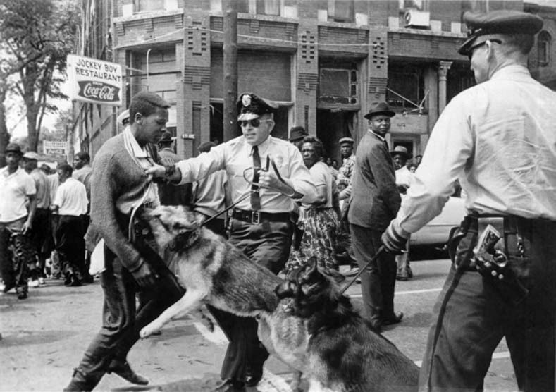
Student attacked by police dogs during 1963 Birmingham protests.
Images of civil rights protestors being attacked with fire hoses and police dogs captured the nation’s attention and galvanized public support for the civil rights movement in the 1960s. Graphic images conveyed to a national audience the violent reality of segregation and led to widespread calls for action. Images of protests and the response of local officials “struck like lightning in the American mind . . . searing the conscience of the nation.” Their impact is considered one of the chief reasons for the movement’s success, as embodied in the passage of the Civil Rights Act of 1964, Pub. L. No. 88-352, 78 Stat. 241. The images “of struggle and resistance, of police brutality and violent confrontation,” id., remain the most powerful and enduring account of a time of momentous change.

Images deeply influenced views of the Vietnam War.
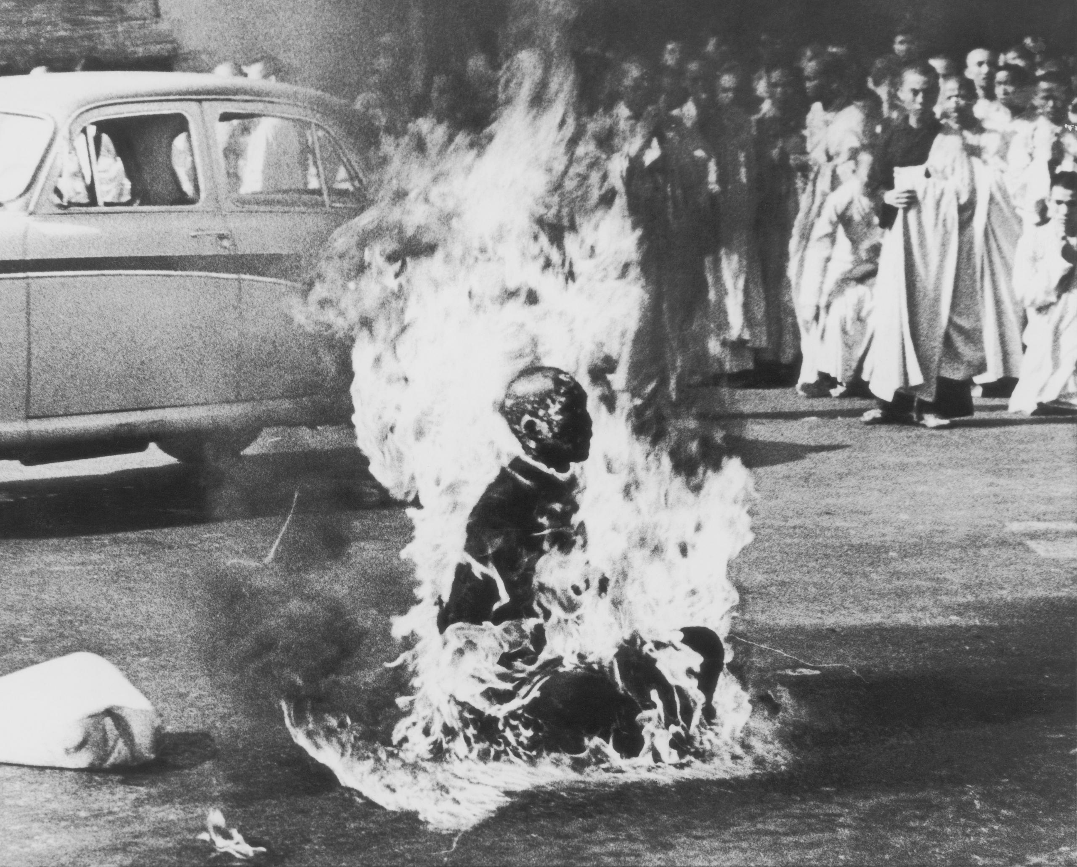
Vietnamese monk’s protest by self-immolation before the War.

Images of the Vietnam War were also decisive in shaping public debate. Vietnam is often called the “living room war” because filmed recordings brought home on television news the reality of war. Images of the war engendered and entrenched public opposition to American involvement in Vietnam.
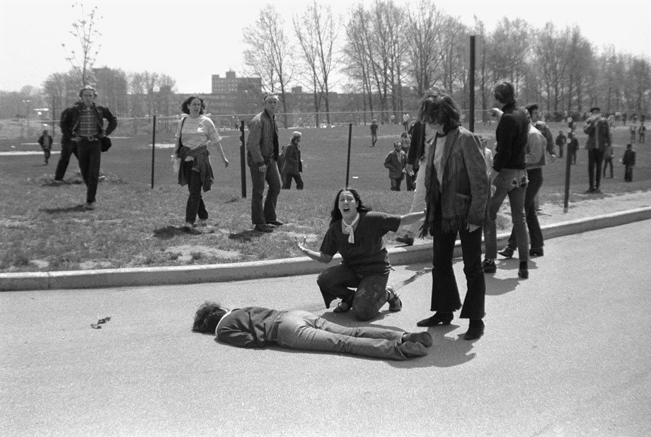
Mary Ann Vecchio beside the body of Jeffrey Miller.
Consequential images were not always from the war zone. Some believe that “the Kent State shootings helped turn the tide against the Vietnam War more than any other single event,” in no small part due to the iconic photograph of Mary Ann Vecchio kneeling over the body of Jeffrey Miller, one of four casualties. This and many other shocking images taken by eyewitnesses helped spark nationwide student strikes and protests. Later, the 2007 discovery of an audio recording of the shootings rekindled controversy concerning the National Guard’s reason for opening fire—another example of how recording contributes to the public understanding of important events.

Bystander recordings have prompted debates on policing.
More recently, video recordings have informed and inspired public debate over policing and race, confirming the importance of recording to public debate.
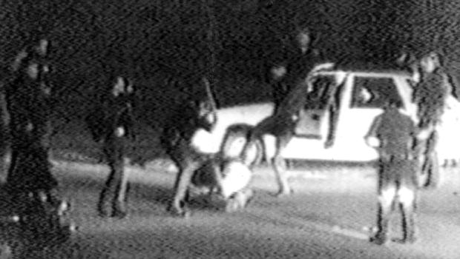
Rodney King’s beating in Los Angeles.
George Holliday’s video of Rodney King being beaten by Los Angeles Police Department officers, for example, “turned what would otherwise have been a violent, but soon forgotten encounter . . . into one of the most widely watched and discussed events of its time.” “If a man had not stepped outside and videotaped the beating, King would have been lost to history.” Widespread dissemination of the video made evident the deep tensions over policing in African-American communities, sparking massive protests and nationwide debate.
A spate of highly controversial police shootings and acts of violence captured on cell phone video have recently brought these issues back to the center of public attention. For instance, recordings made by multiple bystanders of the shooting of Oscar Grant were crucial to the Alameda County District Attorney’s decision to bring a murder charge against the officer who fired the fatal shots. A video of Eric Garner’s death similarly attracted nationwide attention, offering key support for the medical examiner’s conclusion that his death was caused by the police:
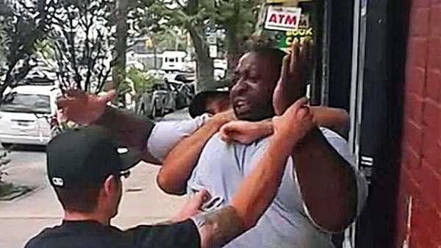
A New York police officer chokeholds Eric Garner.
An audio recording that captured the sound of gunshots provided important evidence in the investigation of Michael Brown’s death, which sparked broad protests in Ferguson, Missouri. The existence of recorded accounts of these incidents was crucial in fomenting public discussion and shaping the legal response.
In short, time and again, national conversations regarding issues of enormous societal importance have centered on recordings. It often takes only a single video or photograph to bring issues to the fore of public debate.

Recording Matters Of Public Concern Is Covered By The First Amendment As An Essential Precursor To Speech.
The protections of the First Amendment necessarily extend, at the very least, to the act of recording any matter of public concern that one is lawfully able to observe. Otherwise, the core right to speak on public issues could itself be frustrated simply by regulating earlier and essential parts of the process of expression. Public debate and the search for truth would be substantially impaired.

The First Amendment broadly seeks to protect the free flow of information on matters of public concern.
The proper application of the First Amendment to new technologies requires a clear understanding of the fundamental role it plays in American democracy. The First Amendment broadly protects the “free flow of ideas and opinions on matters of public interest and concern.” Hustler Magazine, Inc. v. Falwell, 485 U.S. 46, 50 (1988)
. It does so in order “to ensure that the individual citizen can effectively participate in and contribute to our republican system of self-government.” Globe Newspaper Co. v. Superior Court, 457 U.S. 596, 604 (1982)
. The First Amendment’s protections reflect our national commitment that “debate on public issues should be uninhibited, robust, and wide-open.” New York Times Co. v. Sullivan, 376 U.S. 254, 270 (1964)
. They also ensure that the debate is an informed one, capable of advancing knowledge, discovering truth and allowing rational decisions. See, e.g., Kleindienst v. Mandel, 408 U.S. 753, 762-63 (1972)
; Curtis Pub. Co. v. Butts, 388 U.S. 130, 147 (1967)
; Time, Inc. v. Hill, 385 U.S. 374, 389 (1967)
; Garrison v. Louisiana, 379 U.S. 64, 74-75 (1964)
; Bridges v. California, 314 U.S. 252, 277-78 (1941)
; Near v. Minnesota, 283 U.S. 697, 721-22 (1931)
.
We safeguard the freedoms of speech and press, the right to assemble, and other First Amendment rights so that people “may speak as they think on matters vital to them and that falsehoods may be exposed through the processes of education and discussion [that] is essential to free government.” Thornhill v. Alabama, 310 U.S. 88, 95 (1940)
; see also Letter to the Inhabitants of Quebec, reprinted in 1 Journals of the Continental Congress, 1774-1789, pp. 101, 108 (Worthington C. Ford ed. 1904) (defending press freedom for its ability to disseminate informed views about government and “its consequential promotion of union” among citizens). The First Amendment was adopted to prevent “any action of the government by means of which it might prevent such free and general discussion of public matters as seems absolutely essential to prepare the people for an intelligent exercise of their rights as citizens.” Thomas M. Cooley, A Treatise on the Constitutional Limitations Which Rest upon the Legislative Power of the States of the American Union 422 (1868).
In keeping with these constitutional objectives, the First Amendment “embodies more than a commitment to free expression and communicative interchange for their own sakes; it has a structural role to play in securing and fostering our republican system of self-government.” Richmond Newspapers, Inc. v. Virginia, 448 U.S. 555, 587 (1980)
(Brennan, J., concurring). Because individuals must be informed in order to participate meaningfully in public life, the First Amendment protects not only the right to communicate, but also “the right of the public to receive suitable access to social, political, esthetic, moral, and other ideas and experiences.” Red Lion Broad. Co. v. FCC, 395 U.S. 367, 390 (1969)
(emphasis added). Access to such knowledge ensures that individuals have the information they need “to decide for [themselves] the ideas and beliefs deserving of expression, consideration, and adherence.” Turner Broad. Sys., Inc. v. FCC, 512 U.S. 622, 641 (1994)
. This principle lies “[a]t the heart of the First Amendment.” Id.
Accordingly, First Amendment protection extends beyond pure speech. The First Amendment must be construed “to encompass those rights that, while not unambiguously enumerated in the very terms of the Amendment, are nonetheless necessary to the enjoyment of other First Amendment rights.” Globe Newspaper, 457 U.S. at 604 (citations omitted); see also NAACP v. Button, 371 U.S. 415, 429 (1963)
(noting that “a State cannot foreclose the exercise of constitutional rights by mere labels”). Stated differently, the First Amendment covers not only the “communication itself, but also the indispensable conditions of meaningful communication.” Richmond Newspapers, 448 U.S. at 588 (Brennan, J., concurring).
Consistent with this understanding, the Supreme Court on several occasions has noted that the act of seeking out information on matters of public concern itself is encompassed by the First Amendment, or else the “‘freedom of the press could be eviscerated.’” Id. at 576 (quoting Branzburg v. Hayes, 408 U.S. 665, 681 (1972)
). If the First Amendment afforded no protection to the gathering of newsworthy information, then the government could prevent unwanted information from being published simply by targeting acts that are necessary to the creation of the protected speech itself. See Ashutosh Bhagwat, Producing Speech, 56 Wm. & Mary L. Rev. 1029, 1052-54 (2015); see also Richmond Newspapers, 448 U.S. at 580 (construing the First Amendment to require public access to certain government proceedings and records as a “fundamental right . . . indispensable to the enjoyment of rights explicitly defined.”); id. at 583 (Stevens, J., concurring) (“[A]n arbitrary interference with access to important information” is itself “an abridgment of the freedoms of speech and of the press protected by the First Amendment.”).
The First Amendment has thus been found to prohibit restrictions not just on speech but on other steps in the process of gathering information and creating and disseminating expressive content. In Sorrell v. IMS Health Inc., 564 U.S. 552, 564 (2011)
, the Court invalidated a targeted ban on providing certain commercially-valuable information to pharmaceutical salespersons because the law selectively burdened their ability to engage in “marketing, that is, speech with particular content.” In Minneapolis Star & Tribune Co. v. Minnesota Commissioner of Revenue, 460 U.S. 575, 582-83 (1983)
, the Court invalidated, on First Amendment grounds, a use tax on ink and paper that singled out newspapers. And in Buckley v. Valeo, the Court recognized that restrictions on spending for purposes of engaging in communication likewise constitute restrictions on speech. 424 U.S. 1, 19 (1976)
(per curiam).
This precedent firmly establishes that the First Amendment protects more than pure speech and its dissemination. The First Amendment also covers those activities that are needed to make information on matters of public concern available to the public.

First Amendment protection extends specifically to the act of recording matters of public concern.
As demonstrated above, the coverage of the First Amendment extends to the entire process of public discourse, a process that includes observing, listening, and collecting information necessary for informed dialogue. The First Amendment ensures that individuals are free to recall, comment upon, and assess for themselves what they have witnessed with their own eyes and ears. It equally covers the use of modern technologies to augment these long-protected activities. Interfering with any stage of this process necessarily raises First Amendment concerns. See Citizens United v. Fed. Election Comm’n, 558 U.S. 310, 336 (2010)
(“Laws enacted to control or suppress speech may operate at different points in the speech process.”).
This Circuit has previously affirmed that the entire process of creating protected “speech” is covered by the First Amendment:
[N]either the Supreme Court nor our court has ever drawn a distinction between the process of creating a form of pure speech (such as writing or painting) and the product of these processes (the essay or the artwork) in terms of the First Amendment protection afforded. Although writing and painting can be reduced to their constituent acts, and thus described as conduct, we have not attempted to disconnect the end product from the act of creation.
Anderson v. City of Hermosa Beach, 621 F.3d 1051, 1061-62 (9th Cir. 2010)
; see also, e.g., Vincenty v. Bloomberg, 476 F.3d 74, 87 (2d Cir. 2007)
(statute prohibiting youth possession of spray paint and felt-tipped markers in public places was likely violation of First Amendment).
The logic of these cases—that interference with the process of generating speech or expressive activity is itself an interference with free speech—applies fully to restrictions on the act of recording. Throughout history, technological advances have facilitated the ability to recall and recount one’s observations of events, and First Amendment protections have kept pace. From protecting the oral and printed word to protecting motion pictures, radio and television broadcasts, cable television and the Internet, new technologies have received the protection necessary to ensure that the societal benefits of free expression intended by the First Amendment are maintained.
The same must be true for recording technologies that give citizens today unparalleled power to capture and communicate events. The First Amendment protects an individual’s right to record and post a matter of public concern today just as it protected an individual’s right to remember and report events in a newspaper at the time of our founding. The freedoms and objectives intended by the First Amendment should properly remain constant, even as technology evolves.
Courts have long recognized that the act of playing or broadcasting recorded images is protected by the First Amendment because it fosters informed public discourse. See, e.g., Turner, 512 U.S. at 636; Leathers v. Medlock, 499 U.S. 439, 444 (1991)
. The act of recording is a necessary precursor to this playback, and for purposes of the First Amendment this precursor must also be protected, particularly where matters of public concern are involved. In the words of the Seventh Circuit, “[t]he act of making an audio or audiovisual recording is necessarily included within the First Amendment’s guarantee of speech and press rights as a corollary of the right to disseminate the resulting recording.” ACLU of Ill. v. Alvarez, 679 F.3d 583, 595 (7th Cir. 2012)
.
Indeed, this Court has previously concluded that an alleged violation of a “First Amendment right to film matters of public interest” stated a triable claim, albeit in a ruling affirming dismissal on procedural grounds. Fordyce v. City of Seattle, 55 F.3d 436, 439 (9th Cir. 1995)
. Several other Circuits have also acknowledged, in various contexts, the existence of First Amendment protection for the act of recording matters of public concern. See Alvarez, 679 F.3d at 608 (7th Cir. 2012) (striking down anti-eavesdropping law for interfering with “an expressive medium used for the preservation and dissemination of information and ideas”); Glik v. Cunniffe, 655 F.3d 78, 85 (1st Cir. 2011)
(recognizing right to record police officers); Smith v. City of Cumming, 212 F.3d 1332, 1333 (11th Cir. 2000)
(recognizing “specifically, a right to record matters of public interest”); see also Demarest v. Athol/Orange Cmty. Television, Inc., 188 F. Supp. 2d 82, 94-95 (D. Mass. 2002)
(community television producers have “constitutionally protected right to record matters of public interest”); Cirelli v. Town of Johnston Sch. Dist., 897 F. Supp. 663, 669 (D.R.I. 1995)
(teachers have right to videotape health code violations at school). These holdings properly respect the relationship between recording and civic engagement, and recognize that the act of recording is inextricably linked to the constitutional goals of the First Amendment. See Seth F. Kreimer, Pervasive Image Capture and the First Amendment: Memory, Discourse, and the Right to Record, 159 U. Pa. L. Rev. 336, 366-69 (2011).
This Court should hold expressly that the First Amendment covers the act of recording at least matters of public concern. Recognizing such a right ensures that facts can be captured in more accurate detail than allowed by mere recollection, and conveyed with far greater precision than by mere words. It empowers citizens to more fully present truths that inform debate.

The right to record extends to all matters of public concern that one lawfully observes, even on private property.
The strong constitutional interest in the protection of recording exists for events of public concern that occur in both public fora and on private property. Events central to public debate on matters of legitimate public interest can occur anywhere, and the First Amendment’s protections extend to speech concerning newsworthy events, wherever they occur. See, e.g., City of Ladue v. Gilleo, 512 U.S. 43, 59 (1994)
(O’Connor, J., concurring) (content discrimination in the regulation of speech is presumptively impermissible, whether “on private property or in a traditional public forum”); accord Reed v. Town of Gilbert, 135 S. Ct. 2218, 2232 (2015)
(regulation of signs on private property subject to strict scrutiny); R.A.V. v. City of St. Paul, 505 U.S. 377, 391 (1992)
(invalidating statute prohibiting certain symbols on “public or private property”).
This is not to say that such recording can never be regulated by the State; nor does it suggest that private parties, relying on garden-variety trespass and similar laws, may not impose limitations on access to and therefore ability to record on private property. Rather, the existence of a right to record matters of public concern simply means that regulations that restrict such recordings are subject to scrutiny under established First Amendment doctrines.
While private property owners may thus impose various restrictions on recording on their property, the First Amendment does not permit the government to impose criminal prohibitions against recording specific matters of public concern by individuals who are lawfully present and able to observe them. Allowing States to criminalize the unauthorized recording of specific matters of public concern on private property would stop much democratic engagement in its tracks. If constitutionally permissible, such content-based restraints would prevent the public from learning information directly relevant to policy debates and allow the government to target disfavored speakers or speech.
The meat and agricultural production industries, the specific beneficiaries of the Idaho Act at issue, provide prime examples of private entities that have been subjects of legitimate public debate for decades. At the turn of the 20th century, written eyewitness accounts of the meat-packing industry, including Upton Sinclair’s The Jungle (1906), triggered a nationwide debate and helped to create a regulatory regime to protect public health and worker safety. The Federal Meat Inspection Act, Pub. L. No. 59-242, 34 Stat. 1260 (codified as amended at 21 U.S.C. §§ 601-695), and the Pure Food and Drug Act, Pub. L. No. 59-384, 34 Stat. 768 (codified as amended at 21 U.S.C. §§ 301-399f), both adopted in 1906, recognized the strong public interest in the safety of the Nation’s food supply. The food production industry remains subject to regulation today by both the Department of Agriculture and the Food and Drug Administration.
Undercover investigations facilitated by newer recording technologies have reignited old debates, exposing unsanitary, unsafe, and inhumane practices that persist in some slaughterhouses. For example, an undercover investigator obtained video of “inhumane handling of non-ambulatory disabled cattle.” The video included attempts to forcibly move animals with electric prods and forklifts:
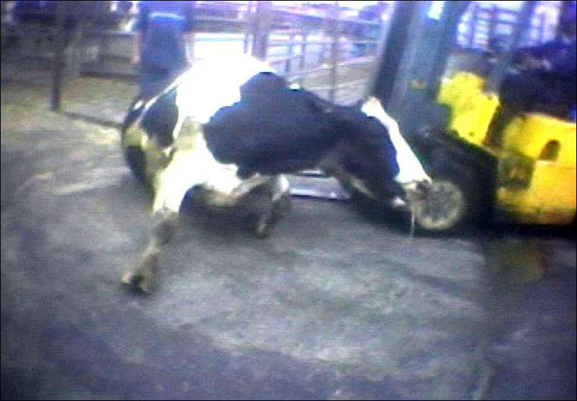
A still from the undercover video.
This video has been viewed millions of times and has sparked thousands of online comments.
Beyond simply exposing troubling practices, these recordings revealed a potentially serious health risk—“downed” cattle, unable to move under their own power, can be suffering from mad cow disease. The release of the recordings spurred major distributors to end affiliations with producers, resulted in suspension of the facility’s operations by the USDA, and prompted a subpoena and Congressional hearing for the company’s CEO. The incident also motivated broad support for food safety reform, culminating in passage of a USDA rule completely banning the slaughter of downed cattle. 9 C.F.R. § 309.3 (2009).
Attempts to assert claims such as trespass, breach of duty of loyalty, and theft of trade secrets have been unsuccessful in suppressing news reports that include undercover recordings, which is precisely why the Idaho statute at issue now seeks to declare such recording illegal. In keeping with its own past decision not to “draw[] a hard line between the essays John Peter Zenger published and the act of setting the type,” Anderson, 621 F.3d at 1062, this Court should affirm that First Amendment coverage extends to the act of recording any matter of public concern that one is lawfully able to observe.

IDAHO CODE § 18-7042(1)(d) VIOLATES THE FIRST AMENDMENT RIGHT TO RECORD.
Idaho Code § 18-7042(1)(d) prohibits any recording of agricultural facility operations that is not expressly authorized by the facility owner or by legal process, directly restricting the First Amendment right to record. The propriety of this restriction must be evaluated under the same First Amendment standards applied to direct restrictions on speech. In this case, the Idaho Act is a content-based restriction on the right to record and is therefore subject to the same strict scrutiny as a content-based restriction on speech. The Idaho Act cannot survive this scrutiny. Singling out recording in agricultural production facilities for criminal punishment imposes an unconstitutional burden and improperly silences public dialogue on matters of obvious public concern.

The Same First Amendment Standards That Protect Speech Protect Recording Matters of Public Concern.
Supreme Court precedent demonstrates that laws restricting activity covered by the First Amendment are judged under the same First Amendment standards that apply to laws restricting speech. Indeed, the Court has often evaluated such restrictions as if they were restrictions on speech itself.
Citizens United v. FEC provides one example of the required approach. The plaintiff was prohibited by statute from spending corporate funds to advertise a political film—not from the speech acts of advertising or showing the film, only from the necessary precursor of spending money. While the plaintiff was not prohibited from expressing its political opinions directly, it was prohibited from performing an act essential to doing so. The Court thus evaluated the prohibition on corporate independent expenditures as if it were “a ban on speech.” Citizens United, 558 U.S. at 339. Because the prohibition banned a necessary precursor to political speech, the Court applied the same level of scrutiny that would apply to a restriction on political speech itself, strict scrutiny. See id. at 340.
Minneapolis Star & Tribune Co. v. Minnesota Commissioner of Revenue provides another example. In that case, the Court invalidated a use tax on ink and paper because it singled out for taxation newspapers in general, and some newspapers in particular. While the statute did not directly prohibit any publication, it did place a burden on an essential precursor to publication: purchasing ink and paper. Because the tax was a non-content based restriction on a precursor to speech, the Court applied the same standard that would apply to a non-content based restriction on speech itself. The Court held that a “tax that burdens rights protected by the First Amendment cannot stand unless the burden is necessary to achieve an overriding governmental interest,” and that this interest must be “unrelated to suppression of expression.” Minneapolis Star & Tribune Co., 460 U.S. at 582, 585. The Minnesota tax was struck down under this standard.
The Seventh Circuit similarly applied the relevant speech-based protection to a restriction on recording in ACLU of Illinois v. Alvarez. In that case, the court considered an Illinois eavesdropping law prohibiting all recording of conversations without the consent of all parties. Because the statute was content-neutral, the court applied intermediate scrutiny, the general standard that governs content-neutral restrictions on speech. Alvarez, 679 F.3d at 603 (citing Turner, 512 U.S. at 641). The court held that the statute likely failed even the lower, intermediate scrutiny standard because it swept too broadly to justify the asserted need to protect conversational privacy. See id. at 605-06.

Section 18-7042(1) Is a Facially Content-Based Restriction That Cannot Survive Strict Scrutiny.
Applying the same approach requires the Idaho Act to be subjected to strict scrutiny because it imposes a content based restriction on First Amendment-protected activity.
A law is facially content-based when it “applies to particular speech because of the topic discussed or the idea or message expressed,” thus “draw[ing] distinctions based on the message a speaker conveys.” Reed, 135 S. Ct. at 2227 (citing Sorrell, 564 U.S. at 563-67). Indeed, Reed cites as an “obvious” example of facially content-based restrictions on speech limitations based on “particular subject matter.” Id. The Idaho Act is facially content-based in just this way. It prohibits “audio or video recording[] of the conduct of an agricultural production facility’s operations,” making its application turn specifically on the content of the matter recorded. Idaho Code § 18-7042(1)(d). Recording a politician’s visit to an agricultural facility is not restricted by the Act; recording the operation of the facility is. Id.
As a content-based restriction recording, the Act is subject to the same First Amendment standard as a content-based restriction on speech. Such restrictions are subject to strict scrutiny and “presumptively invalid.” City of St. Paul, 505 U.S. at 382; see Reed, 135 S. Ct. at 2231; Playboy, 529 U.S. at 813. For § 18-7042(1)(d) to survive strict scrutiny, the State must demonstrate that its restrictions serve a compelling interest, and that those restrictions are narrowly tailored to serve that interest. Reed, 135 S. Ct. at 2231; Citizens United 558 U.S. at 340. The State has not and cannot do so.

No compelling interest justifies Idaho’s restrictions on recording matters of public concern.
Idaho asserts that two interests justify its statutory restriction on recording: the protection of private property and the protection of agricultural facility owners’ privacy. Animal Legal Def. Fund v. Otter, 118 F. Supp. 3d 1195, 1202, 1207 (D. Idaho 2015)
. Neither is among the “few historic and traditional categories of expression” for which content-based restrictions are categorically justified. U.S. v. Alvarez, 132 S. Ct. 2537, 2544 (2012)
(internal quotation omitted) (listing, e.g., true threats, fighting words, obscenity, defamation, fraud, and child pornography); see also City of St. Paul, 505 U.S. at 383.
Nor is either justification among the interests that the Supreme Court in applying strict scrutiny has previously recognized as compelling. See Alvarez, 132 S. Ct. at 2544; Eugene Volokh, Freedom of Speech, Permissible Tailoring and Transcending Strict Scrutiny, 144 U. Pa. L. Rev. 2417, 2420-21 (1997) (listing seven interests, including preserving “the unique role of the press” and several interests relating to elections). The exclusionary and privacy interests of a particular industry are simply not “public necessit[ies]” that justify restrictions that significantly restrict investigation and thus commentary on matters of public concern. Turner, 512 U.S. at 680.
Private property rights are already safeguarded by civil and criminal sanctions for ordinary trespass, and private parties remain free to condition access to private facilities on an agreement not to record. But the First Amendment precludes governments from imposing content-based restrictions on recording matters of public concern by someone who is lawfully present to observe it.
Privacy interests are equally insufficient to justify the Act’s prohibition on recording. The Supreme Court has made clear that “[p]rivacy concerns give way when balanced against the interest in publishing matters of public importance.” Bartnicki v. Vopper, 532 U.S. 514, 534 (2001)
. Protecting truthful speech on matters of public concern is one of “the core purposes” of the First Amendment, id. at 533-34, and “at the heart of [its] protection[s].” Snyder v. Phelps, 562 U.S. 443, 451-52 (2011)
. Privacy concerns thus also generally “give way” when balanced against the right to record a matter of public concern.
“Speech deals with matters of public concern when it can ‘be fairly considered as relating to any matter of political, social, or other concern to the community,’” Snyder, 562 U.S. at 453 (quoting Connick v. Myers, 461 U.S. 138, 146 (1983)
), or when it is “‘a subject of general interest and of value and concern to the public.’” Id. (quoting City of San Diego v. Roe, 543 U.S. 77, 84 (2004)
). Food production conditions undoubtedly meet this standard. Americans have deep interests in how their food is raised and prepared, including assuring the humane treatment of animals and investigating food safety concerns.
The First Amendment does not permit Idaho to restrict recordings that implicate such matters of paramount public importance. Because the agricultural industry is central to the health and well-being of society, it must remain subject to free, reasoned, and accurate debate.

Idaho’s recording restriction is not narrowly tailored.
Even assuming arguendo that property and industrial privacy interests are compelling, to survive strict scrutiny the Idaho Act must still be “narrowly tailored” to protect those interests. It is not. Section 18-7042(1)(d) does not restrict only those recordings produced by trespass or exposing private affairs to the public eye. Instead, its restrictions reach accurate, truthful recordings that may not depict any identifiable human beings at all (thus not threatening an individual privacy interest), as well as those taken by lawfully present individuals (thus not threatening an exclusionary property interest). Rather than narrowly protecting the interests asserted to justify the Act, Idaho is restricting the flow of true information on matters of legitimate public concern.
It is beyond dispute that a lawfully present witness to animal abuse, unsafe or unsanitary practices, or any other matter of public concern is entitled to speak about and recount what she has seen. Such a person violates no property rights so long as her presence is lawful and permitted; her subsequent reporting violates no privacy rights so long as it relates to subjects of preponderant public importance. Recording can only increase the accuracy and quality of this speech and provides a powerful element to that discourse; criminalizing this recording threatens to silence or at least disadvantage one side of this debate. “Society has the right and civic duty to engage in open, dynamic, rational discourse.” Alvarez, 132 S. Ct. at 2550. Because it inhibits speech of legitimate public concern, § 18-7042(1)(d) is decisively overbroad.
The provision is also unnecessary. Those who suffer legally cognizable harms to their privacy and property interests may turn to any number of other sources of redress. Private parties may exclude others from their property under trespass laws, and may ban recordings or their dissemination through contracts and nondisclosure agreements. Malicious, falsified recordings and accounts may give rise to liability for fraud or defamation. Aggrieved private parties thus have “various other laws at [their] disposal” by which Idaho can “achieve its stated interests while burdening little or no speech.” Comite de Jornaleros v. City of Redondo Beach, 657 F.3d 936, 949 (9th Cir. 2011)
; accord Alvarez, 132 S. Ct. at 2551 (“[W]hen the Government seeks to regulate protected speech, the restriction must be the ‘least restrictive means among available, effective alternatives.’”) (quoting Ashcroft, 542 U.S. at 666).
Section 18-7042(1)(d) imposes criminal penalties on the exercise of First Amendment-protected activity, and does not meaningfully further the State’s asserted interests. This exercise of state power to prohibit the recording of agricultural operations, and thus stifle discussion of matters of legitimate public debate, is unjustifiable, overbroad, and impermissible under the First Amendment.

CONCLUSION
For the foregoing reasons, the order of the district court should be affirmed.
Dated: June 27, 2016 | Respectfully submitted,
/s/ David A. Schulz
David A. Schulz
Media Freedom & Information Access Clinic
Abrams Institute
Yale Law School
321 West 44th Street, Suite 1000
New York, NY 10036
(212) 850-6100
dschulz@lskslaw.com
Jonathan Manes
P.O. Box 208215
New Haven, CT 06520-8215
(203) 432-9387
Counsel for Amici Abrams Institute for Freedom of Expression and Scholars of First Amendment and Information Law*

APPENDIX (List of Amici Curiae)†
The Abrams Institute for Freedom of Expression at Yale Law School promotes freedom of speech, freedom of the press, and access to information as informed by the values of democracy and human freedom. The Institute’s mission is both practical and scholarly, supporting litigation and law reform efforts as well as academic scholarship, conferences, and other events on First Amendment and related issues.

Enrique Armijo
Associate Professor of Law and Associate Dean for Academic Affairs
Elon University School of Law

Jack M. Balkin
Knight Professor of Constitutional Law and the First Amendment
Yale Law School

Derek Bambauer
Professor of Law
University of Arizona James E. Rogers College of Law

Jane Bambauer
Associate Professor of Law
University of Arizona James E. Rogers College of Law

Samantha Barbas
Associate Professor of Law
University at Buffalo School of Law

Ashutosh Bhagwat
Martin Luther King, Jr. Professor of Law
University of California Davis School of Law

Marc Jonathan Blitz
Alan Joseph Bennett Professor
Oklahoma City University School of Law

Joseph Blocher
Professor of Law
Duke Law School

Annemarie Bridy
Professor of Law
University of Idaho College of Law

Eric M. Freedman
Siggi B. Wilzig Distinguished Professor of Constitutional Rights
Maurice A. Deane School of Law at Hofstra University

Jane E. Kirtley
Silha Professor of Media Ethics and Law
School of Journalism and Mass Communication, University of Minnesota
Affiliated Faculty Member, University of Minnesota Law School

Thomas Healy
Professor of Law
Seton Hall University School of Law

Stephen E. Henderson
Judge Haskell A. Holloman Professor of Law
University of Oklahoma College of Law

Margot E. Kaminski
Assistant Professor of Law
Ohio State University Moritz College of Law

Jeremy K. Kessler
Associate Professor of Law
Columbia Law School

Heidi Kitrosser
Professor of Law
University of Minnesota Law School

Seth F. Kreimer
Kenneth W. Gemmill Professor of Law
University of Pennsylvania Law School

Lyrissa Barnett Lidsky
Stephen C. O’Connell Professor of Law
University of Florida Levin College of Law

Helen Norton
Professor and Ira C. Rothberger, Jr. Chair in Constitutional Law
University of Colorado School of Law

Tamara R. Piety
Phyllis Hurley Frey Professor of Law
University of Tulsa College of Law

Joseph Thai
Glenn R. Watson Centennial Chair and Presidential Professor
University of Oklahoma College of Law

Alexander Tsesis
Raymond & Mary Simon Chair in Constitutional Law and Professor of Law
Loyola University Chicago School of Law

Rebecca Tushnet
Professor of Law
Georgetown Law

Timothy Zick
Mills E. Godwin, Jr. Professor of Law
William & Mary Law School
CERTIFICATE OF COMPLIANCE WITH RULE 32(a)

This brief complies with the type-volume limitation of Rule 29(d) of the Federal Rules of Appellate Procedure because it is 6,997 words, excluding the parts of the brief exempted by Rule 32(a)(7)(B)(iii).
This brief complies with the typeface requirements of Rule 32(a)(5) of the Federal Rules of Appellate Procedure and the type-style requirements of Rule 32(a)(6) of the Federal Rules of Appellate Procedure because this brief has been prepared in a proportionally spaced typeface using Microsoft Office Word 2010, in 14-point Times New Roman font.

/s/David A. Schulz
David A. Schulz

Dated: June 27, 2016

CERTIFICATE OF SERVICE

I hereby certify that I electronically filed the foregoing with the Clerk of the Court for the United States Court of Appeals for the Ninth Circuit by using the appellate CM/ECF system on June 27, 2016.
I certify that all participants in the case are registered CM/ECF users and that service will be accomplished by the appellate CM/ECF system.

/s/David A. Schulz
David A. Schulz

Dated: June 27, 2016

Justin Marceau & Alan Chen, Free Speech and Democracy in the Video Age, 116 Colum. L. Rev. 991, 1000 (2016).
AP/Bill Hudson, Photograph of Parker High School Student Walter Gadsden Being Attacked by Dogs (1963), https://upload.wikimedia.org/wikipedia/en/‌7/74/Birmingham_campaign_dogs.jpg .
See Davi Johnson, Martin Luther King’s 1963 Birmingham Campaign as Image Event, 10 Rhetoric & Pub. Affairs 1, 4-7, 16-18 (2007).
Id. at 5 (internal quotation omitted). See also Leigh Raiford, “Come Let Us Build a New World Together”: SNCC and Photography of the Civil Rights Movement, 59 American Quarterly 1129, 1129-30 (2007).
See David J. Garrow, Foreword to Martin A. Berger, Seeing Through Race: A Reinterpretation of Civil Rights Photography, at x (2011).
AP/Malcolm W. Browne, Saigon, Vietnam Buddhist Monk Thích Quảng Đức Sets Himself Ablaze to Protest the South Vietnamese Government (1963), http://www.worldpressphoto.org/sites/default/files/styles/gallery_main_image/public/1963001.jpg .
Patrick Hagopian, Vietnam War Photography as a Locus of Memory, in Locating Memory: Photographic Acts 201 (A. Kuhn & K. Emiko McAllister eds., 2006).
See id. at 205-09; Haim Bresheeth, Projecting Trauma: War Photography and the Public Sphere, 20 Third Text 57, 62-63 (2006); Daniel C. Hallin, The “Uncensored War”: The Media and Vietnam 3 (1989).
Getty/John Filo, Mary Ann Vecchio Kneels over the Body of Jeffrey Miller at Kent State University, Ohio (1970), http://www.slate.com/content/dam/slate/‌blogs/behold/2013/05/04/7.jpg.CROP.original-original.jpg .
Gary Tuchman, Kent State Forever Linked With Vietnam War Era, CNN (May 4, 2000), http://www.cnn.com/SPECIALS/views/y/2000/04/tuchman.kentstate.‌may4.
See Kent State Shootings Divided Campus and Country, National Public Radio (May 3, 2010), http://www.npr.org/templates/story/story.php?storyId=126480349 .
See Thomas J. Sheeran, Kent State Audio Tape Released, Wash. Post, May 2, 2007, http://www.washingtonpost.com/wp-dyn/content/article/2007/05/02/‌AR2007050200322.html .
KTLA/George Holliday, Image from Video Shows Police Officers Beating Rodney King (1991), http://www.cbsnews.com/‌news/march-3rd-1991-rodney-king-lapd-beating-caught-on-video/ .
Douglas O. Linder, The Holliday Videotape, Famous Trials, http://law2.umkc.edu/faculty/projects/ftrials/lapd/kingvideo.html .
The Lessons We Learned From Rodney King, National Public Radio (June 18, 2012), http://www.npr.org/2012/06/18/155296745/the-lessons-we-learned-from-rodney-king .
See Matthew B. Stannard & Demian Bulwa, BART Shooting Captured on Video, SFGate (Jan. 7, 2009), http://www.sfgate.com/bayarea/article/BART-shooting-captured-on-video-3177850.php ; Demian Bulwa, Wyatt Buchanan & Matthew Yi, Behind Murder Charge Against Ex-BART Officer, SFGate (Jan. 15, 2009), http://www.sfgate.com/bayarea/article/Behind-murder-charge-against-ex-BART-officer-3254683.php .
See Al Baker, J. David Goodman & Benjamin Mueller, Beyond the Chokehold: The Path to Eric Garner’s Death, N.Y. Times (June 13, 2015), http://www.nytimes.com/2015/06/14/nyregion/eric-garner-police-chokehold-staten-island.html.
Getty/New York Daily News, NYPD Chokehold Death Ruled a Homicide (2014), http://abcnews.go.com/US/nypd-chokehold-death-homicide-medical-examiner-rules/story?id=24811834 .
See Holly Yan, Attorney: New Audio Reveals Pause in Gunfire When Michael Brown Was Shot, CNN (Aug. 27, 2014), http://www.cnn.com/2014/08/26/us/‌michael-brown-ferguson-shooting/index.html .
See Eliott C. McLaughlin, We’re Not Seeing More Police Shootings, Just More News Coverage, CNN (Apr. 21, 2015), http://www.cnn.com/2015/04/20/us/police-brutality-video-social-media-attitudes/ (“‘There’s now no way [the existence of police violence] can be disputed.’”).
See, e.g., Brown v. Entm’t Merch. Ass’n, 564 U.S. 786, 790 (2011) (First Amendment protects video games); Ashcroft v. ACLU, 542 U.S. 656, 666 (2004) (Internet communications); U.S. v. Playboy Entm’t Grp., Inc., 529 U.S. 803, 813 (2000) (cable television); FCC v. League of Women Voters of Cal., 468 U.S. 364, 382 (1984) (broadcast television); FCC v. Pacifica Found., 438 U.S. 726, 737-38 (1978) (radio); Joseph Burstyn, Inc. v. Wilson, 343 U.S. 495, 502 (1952) (cinema); Universal City Studios, Inc. v. Corley, 273 F.3d 429, 447 (2d Cir. 2001) (software).
Numerous state courts have also recognized the First Amendment right to record. See, e.g., People v. Clark, 6 N.E.3d 154, 159 (Ill. 2014) ; Ex parte Thompson, 442 S.W.3d 325, 337 (Tex. Crim. App. 2014) ; Ramos v. Flowers, 56 A.3d 869, 877 (N.J. Super. Ct. App. Div. 2012) ; State v. Bonner, 61 P.3d 611, 614 (Idaho Ct. App. 2002) .
See, e.g., David Greenberg, How Teddy Roosevelt Invented Spin, The Atlantic (Jan. 24, 2016), http://www.theatlantic.com/politics/archive/2016/01/how-teddy-roosevelt-invented-spin/426699/ ; Karen Olsson, Welcome to The Jungle, Slate (July 10, 2006), http://www.slate.com/articles/arts/books/2006/07/‌welcome_to_the_jungle.html .
Humane Society of the United States, Rampant Animal Cruelty at California Slaughter Plant (Jan. 30, 2008), http://www.humanesociety.org/news/news/‌2008/01/undercover_investigation_013008.html .
AP/The Toledo Blade, Image from Video Showing Slaughterhouse Worker Attempting to Force “Downed” Cow onto Its Feet by Ramming It with Forklift in Chino, Calif. (2008), http://www.toledoblade.com/‌image/2013/03/17/‌800x_b1_cCM_z/‌Undercover-Video-Bills-3-18.jpg.
The Humane Society of the United States, Slaughterhouse Investigation: Cruel and Unhealthy Practices, YouTube (Jan. 30, 2008), https://www.youtube.com/‌watch?v=zhlhSQ5z4V4 .
See Matthew L. Ward, Meat Packer Admits Slaughter of Sick Cows, N.Y. Times (Mar. 13, 2008), http://www.nytimes.com/2008/03/13/business/13meat.html .
See, e.g., Anna Schechter, Tyson Foods Changes Pig Care Policies After NBC Shows Undercover Video, NBC News (Jan. 10, 2014), http://investigations.nbcnews.com/_news/2014/01/10/22245308-tyson-foods-changes-pig-care-policies-after-nbc-shows-undercover-video ; M.L. Johnson, DiGiorno, Supplier Drop Dairy Farm Over Abuse, USA Today (Dec. 10, 2013), http://www.usatoday.com/story/money/business/2013/12/10/digiorno-supplier-drop-dairy-farm-over-abuse/3969615/ ; Cynthia Galli, Angela Hill & Rym Momtaz, McDonald’s, Target Dump Egg Supplier After Investigation, ABC News (Nov. 18, 2011), http://abcnews.go.com/Blotter/mcdonalds-dumps-mcmuffin-egg-factory-health-concerns/story?id=14976054 ; Melissa Allison, Costco Stops Buying Pork from Farm Shown in Undercover Video, Seattle Times (July 1, 2011), http://old.seattletimes.com/html/businesstechnology/2015486505_costco02.html .
Statement by Secretary of Agriculture Ed Schafer Regarding Animal Cruelty Charges Filed at Hallmark/Westland Meat Packing Company, U.S. Dep’t of Agric. (Feb. 15, 2008), http://www.usda.gov/wps/portal/usda/usdahome?‌contentidonly=true&contentid=2008/02/0044.xml ; see also Ward, supra note 27.
Agriculture Secretary Tom Vilsack Announces Final Rule for Handling of Non-Ambulatory Cattle, U.S. Dep’t of Agriculture (Mar. 14, 2009), http://www.usda.gov/wps/portal/usda/usdamediafb?contentid=2009/03/0060.xml .
See CBS, Inc. v. Davis, 510 U.S. 1315, 1317-18 (1994) (Blackmun, J., as Circuit Justice); Joan Biskupic & Howard Kurtz, ‘48 Hours’ Wins 11th-Hour Case to Show Undercover Videotape, Wash. Post (Feb. 10, 1994), https://www.washingtonpost.com/archive/politics/1994/02/10/48-hours-wins-11th-hour-case-to-show-undercover-videotape/06f56302-e2e2-4e5f-b62b-6078f80f3b91/ .
Alvarez explicitly did not decide whether conversational privacy is a substantial governmental interest for intermediate scrutiny purposes and its holding does not imply that wiretap statutes violate the First Amendment. See id. at 607-08.
Amici do not address the constitutionality of the other provisions of the Idaho law that have been challenged. Those provisions impose special prohibitions and penalties on individuals who enter, obtain records, or obtain employment from an agricultural production facility by “misrepresentation” or certain other means. Idaho Code § 18-7042(1)(a)-(c), (3)-(4). Amici note, however, that extraordinary, targeted restrictions that are enacted for the purpose of suppressing unfavorable publicity raise issues that are not present with respect to ordinary, all-purpose trespass laws and the like. See, e.g., Turner, 512 U.S. at 662 (“content-neutral restrictions that impose an incidental burden on speech” are only permissible “‘if the governmental interest is unrelated to the suppression of free expression’”) (quoting U.S. v. O’Brien, 391 U.S. 367, 377 (1968) ); Cohen v. Cowles Media Co., 501 U.S. 663, 670 (1991) (laws that “target or single out the press” are subject to special First Amendment scrutiny).
It is unclear whether agricultural production facilities even have a cognizable privacy interest in how they conduct their businesses. See FCC v. AT&T, 562 U.S. 397, 409 (2011) (corporation lacks “personal privacy” interest); Restatement (Second) of Torts § 652I cmt. c (Am. Law Inst. 1977) (“A corporation, partnership or unincorporated association has no personal right of privacy.”).
See Dolf Zillmann, et al., Effects of Photographs in News-Magazine Reports on Issue Perception, 1 Media Psychol. 207, 223-24 (1999) (use of images in news reports influences readers’ perception of issues).
* Counsel wish to thank law students John Ehrett, Yurij Melnyk, Stephen Stich, and Russell Fink for their invaluable contributions to this brief. This brief was prepared by the Media Freedom and Information Access Clinic, a program of the Abrams Institute for Freedom of Expression at Yale Law School. The brief does not purport to express the School’s institutional views, if any.
† Law school affiliations are stated for purposes of identification only.

